Epsom & Ewell F.C.
12
v
Merstham F.C.
Tuesday, 16th January 2018 – 7.45 p.m.
Good evening and welcome to High Road for our League match against Isthmian League Premier Division Merstham. We welcome their players, supporters and officials and wish them a safe journey home, as of course we do for our own regular supporters.

Many supporters from both sides will remember our two season spell as tenants at Moatside and we take this opportunity to thank them for their help over that time. This is the first chance we have had to do this, as our last meetings on the field came way back in 2007/08 when they were having a stellar season which culminated in a Combined Counties League title, a Surrey Senior Cup win and a Quarter-Final appearance in the F.A. Vase. That season we lost 4-1 at home but recorded a highly creditable 1-1 draw at Moatside with a stunning equaliser from Kyle Hough.

In our recent matches we lost 3-2 at Horley Town just before Christmas and then were narrowly defeated 2-0 at home to Walton & Hersham. We then opened the New Year with a 3-0 defeat at Redhill. However, our visit to Godalming last Saturday finally bore fruit when we broke our run of eight losses with a hard-earned 2-1 win. Two new boys Kyen Nicholas and Marlon Pinder were our scorers, and you have to go back to 22nd August 1987 when we last had two players (Clive Gartell, Gary Greenaway) scoring on their debuts. That was so long ago now that Gary’s son Tate now plays against us for Horley Town!

By now most of you will be aware that the club parted company with Glyn Mandeville on Saturday evening and further details are contained within our club statement in today’s programme as well as a few words from our Chairman. In the meantime Neil Grant has stepped up from his role as Coach and is our new Caretaker Manager with effect from today’s match and we wish him luck with the challenges he faces. As all regular supporters know, we are a patient club and Neil will be given every opportunity to turn things around. Indeed he has been responsible for many of the new players joining us over the last couple of months, during which we have seen progress, even though the actual results might not have showed this until the Godalming victory. We’ll bring you more news about our new man in charge in the SCR programme on Saturday 3rd February.

Following today’s match we have two extremely important League fixtures when we host Balham on Saturday and then Abbey Rangers are our visitors in a rearranged fixture next Tuesday. We then visit Spelthorne Sports on 27th January before returning here for the aforementioned SCR match.

Thanks to all of you that have purchased our Centenary merchandise. It is available today and so if you would like to pass our Chairman your money he will let you have your special delivery!

Enjoy the game!

Rich

Don’t forget, you can now follow us on Social Media. Please see the inside cover for addresses.

Cover photos by Gemma Jarman

- Germaine Jeannoel scores our first goal in our recent 2-3 defeat at Horley Town
- Rob Hendry makes sure from the spot in the same match
1
Cherry Red Records Combined Counties League
Premier Division Table 2017/18
inc Saturday 13th January | P | W | D | L | F | A | Pts | GD | H | A
Westfield | 23 | 20 | 1 | 2 | 79 | 23 | 61 | +56 | 14/4 | 0-5
Bedfont Sports | 26 | 18 | 4 | 4 | 70 | 34 | 58 | +36 | 24/3 | 0-7
Walton & Hersham | 26 | 17 | 5 | 4 | 59 | 29 | 56 | +30 | 0-2 | 24/4
Sutton Common Rovers | 26 | 17 | 3 | 6 | 55 | 31 | 54 | +24 | 3/2 | 0-5
Camberley Town | 26 | 9 | 14 | 3 | 35 | 27 | 41 | +8 | 10/3 | 1-1
Hanworth Villa | 26 | 10 | 7 | 9 | 47 | 52 | 37 | -5 | 1-1 | 10/2
Horley Town | 23 | 11 | 4 | 8 | 37 | 44 | 37 | -7 | 2-3 | 2-3
CB Hounslow United | 24 | 11 | 3 | 10 | 40 | 32 | 36 | +8 | 13/2 | 2-4
Spelthorne Sports | 25 | 10 | 6 | 9 | 43 | 36 | 36 | +7 | 1-5 | 27/1
Guildford City | 26 | 10 | 5 | 11 | 46 | 51 | 35 | -5 | 1-3 | 7/4
Knaphill | 24 | 9 | 7 | 8 | 44 | 46 | 34 | -2 | 24/2 | 2-6
Balham | 21 | 9 | 5 | 7 | 39 | 35 | 32 | +4 | 20/1 | 0-4
Redhill | 25 | 9 | 4 | 12 | 41 | 41 | 31 | 0 | 0-5 | 0-3
Abbey Rangers | 22 | 8 | 5 | 9 | 36 | 35 | 29 | +1 | 23/1 | 17/2
North Greenford United | 22 | 7 | 7 | 8 | 38 | 38 | 28 | 0 | 1-2 | 17/3
AFC Hayes | 22 | 7 | 4 | 11 | 32 | 39 | 25 | -7 | 28/4 | 0-2
Chertsey Town | 25 | 7 | 3 | 15 | 43 | 56 | 24 | -13 | 2-7 | 0-1
Farnham Town | 25 | 5 | 6 | 14 | 31 | 47 | 21 | -16 | 3-0 | 0-0
Banstead Athletic | 23 | 5 | 6 | 12 | 30 | 55 | 21 | -25 | 2/4 | 1-1
Colliers Wood United | 23 | 5 | 4 | 14 | 37 | 47 | 19 | -10 | 30/3 | 2-5
Godalming Town | 24 | 4 | 5 | 15 | 26 | 54 | 17 | -28 | 0-3 | 2-1
Epsom and Ewell | 25 | 2 | 4 | 19 | 23 | 79 | 10 | -56 | X | X
1

Lucky Day? – 16th January
Played 11 - Won 5 Drawn 0 Lost 6 - For 19 Against 29 - PPG 1.36 - Average
Our Club record against today’s opponent
Played 11 - Won 6 Drawn 1 Lost 4 - For 29 Against 20 - PPG 1.73 - Good
Our Largest wins and losses against today’s opponent
13th November 1965 - Won 5-0 - Surrey Senior Cup (A)
29th January 2008 - Lost 1-4 - Combined Counties League (H)
Their Last Visit
29th January 2008 - Lost 1-4 - Combined Counties League

First Eleven Appearances 2017/18 - (max 30)
Name | Debut | 2017/18 |  |  |  | Career Totals
 |  | App | Sub | Total | Goals | App | Sub | Total | Goals
AJAYI Tayo | 06/08/2017 | 3 | 4 | 7 | 1 | 3 | 4 | 7 | 1
BROOKS Jordan* | 06/08/2017 | 3 | 0 | 3 | 0 | 3 | 0 | 3 | 0
BURROWES Joshua* | 02/12/2017 | 1 | 1 | 2 | 0 | 1 | 1 | 2 | 0
CASTELL Cristian* | 06/08/2017 | 2 | 4 | 6 | 0 | 2 | 4 | 6 | 0
CONNELLY Lloyd | 14/10/2017 | 15 | 2 | 17 | 2 | 15 | 2 | 17 | 2
DEWAR Ali | 29/10/2011 | 1 | 2 | 3 | 0 | 56 | 42 | 98 | 10
DOBRAJ Endrit | 18/11/2017 | 5 | 3 | 8 | 0 | 5 | 3 | 8 | 0
DYSON Ben | 12/08/2017 | 21 | 4 | 25 | 1 | 21 | 4 | 25 | 1
FRANKLIN Ben | 03/03/2015 | 2 | 1 | 3 | 0 | 3 | 1 | 4 | 0
GRAHAM Bentley | 09/02/2016 | 3 | 0 | 3 | 0 | 20 | 1 | 21 | 3
GRANDISON Kane | 11/11/2017 | 6 | 1 | 7 | 0 | 6 | 1 | 7 | 0
GRIFFIN Reisse | 08/08/2015 | 18 | 0 | 18 | 1 | 91 | 13 | 104 | 7
HARLAND-GODDARD Tom* | 06/08/2017 | 1 | 1 | 2 | 0 | 1 | 1 | 2 | 0
HARRIS Colin* | 04/08/2012 | 9 | 0 | 9 | 0 | 34 | 0 | 34 | 0
HATFIELD Jamie | 11/11/2006 | 9 | 1 | 10 | 0 | 258 | 14 | 272 | 6
HAYWARD Ben | 07/03/2007 | 5 | 1 | 6 | 0 | 248 | 29 | 277 | 18
HEAGNEY Adam | 16/08/2016 | 15 | 2 | 17 | 0 | 52 | 11 | 63 | 1
HENDRY Rob | 08/08/2015 | 15 | 1 | 16 | 5 | 83 | 23 | 106 | 28
HOUGH Kyle | 14/08/2007 | 10 | 2 | 12 | 6 | 343 | 21 | 364 | 207
JASPER Joe* | 11/11/2017 | 0 | 1 | 1 | 0 | 0 | 1 | 1 | 0
JEANNOEL Germaine | 02/12/2017 | 2 | 3 | 5 | 1 | 2 | 3 | 5 | 1
KENNEDY Calum | 18/11/2017 | 2 | 1 | 3 | 0 | 2 | 1 | 3 | 0
LAW Franky* | 06/08/2017 | 3 | 0 | 3 | 0 | 3 | 0 | 3 | 0
LOFTUS-CHEEK Joe | 06/08/2017 | 10 | 3 | 13 | 2 | 10 | 3 | 13 | 2
MARKS Samuel | 06/01/2018 | 1 | 1 | 2 | 0 | 1 | 1 | 2 | 0
MARVELL Dale* | 15/01/2000 | 17 | 2 | 19 | 0 | 286 | 51 | 337 | 86
MASTERSON Shaun | 25/11/2017 | 2 | 2 | 4 | 0 | 2 | 2 | 4 | 0
MCKAY Alex | 20/12/2008 | 16 | 1 | 17 | 1 | 147 | 38 | 185 | 13
MOHAMMED Mohammed* | 23/12/2017 | 3 | 0 | 3 | 0 | 3 | 0 | 3 | 0
MULLINGS Corey | 23/12/2017 | 0 | 2 | 2 | 0 | 0 | 2 | 2 | 0
MURPHY George | 19/03/2013 | 2 | 0 | 2 | 0 | 70 | 7 | 77 | 3
MURPHY Scott | 20/01/2007 | 17 | 0 | 17 | 0 | 29 | 2 | 31 | 1
MYERS Antony | 23/12/2006 | 1 | 0 | 1 | 0 | 76 | 33 | 109 | 9
NICHOLAS Kyen | 13/01/2018 | 1 | 0 | 1 | 1 | 1 | 0 | 1 | 1
NWACHUKWU Jason* | 01/10/2016 | 9 | 4 | 13 | 2 | 26 | 20 | 46 | 3
O'BRIEN Louis* | 28/08/2017 | 1 | 3 | 4 | 0 | 1 | 3 | 4 | 0
PINDER Marlon | 13/01/2018 | 1 | 0 | 1 | 1 | 1 | 0 | 1 | 1
ROBERTS Liam | 12/08/2017 | 14 | 8 | 22 | 4 | 14 | 8 | 22 | 4
ROBINSON Sam* | 22/10/2011 | 5 | 0 | 5 | 0 | 66 | 6 | 72 | 14
ROSE Daniel* | 25/10/2016 | 14 | 2 | 16 | 1 | 16 | 7 | 23 | 1
SMITH Andy* | 25/08/2017 | 2 | 0 | 2 | 0 | 2 | 0 | 2 | 0
SMITH Taryn | 28/10/2017 | 7 | 1 | 8 | 0 | 7 | 1 | 8 | 0
STEW-LEWIS Noah | 09/12/2017 | 3 | 1 | 4 | 0 | 3 | 1 | 4 | 0
THOMPSON Ashley | 21/08/2017 | 21 | 1 | 22 | 3 | 21 | 1 | 22 | 3
THOMSON David* | 02/09/2017 | 2 | 2 | 4 | 0 | 2 | 2 | 4 | 0
TURPIE Ali | 31/03/2016 | 1 | 0 | 1 | 0 | 12 | 1 | 13 | 0
WHITE Sean | 02/08/2014 | 14 | 7 | 21 | 2 | 20 | 20 | 40 | 5
YOUNG Conor | 07/03/2015 | 15 | 0 | 15 | 0 | 16 | 0 | 16 | 0
* Player has left the club

Club Statement – Saturday 13th January 2018
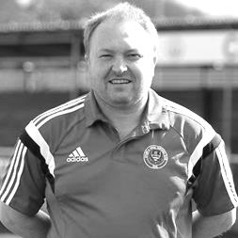
Epsom and Ewell F.C. must advise that Glyn Mandeville has resigned as Manager of our club with immediate effect and we take this opportunity to place on record our thanks for his efforts and achievements over that time.

Glyn joined us in 2011 as an Assistant to Lyndon Buckwell and was a member of our Management team when we won the Combined Counties League Cup in May of 2013. When Lyndon resigned in September 2014 it was an easy decision for the club to appoint him as our new Manager and despite budget cuts that season, he led the team to seventh place, adding two top four finishes in the last two campaigns, the latter of which included another League Cup Final appearance in May of 2017.

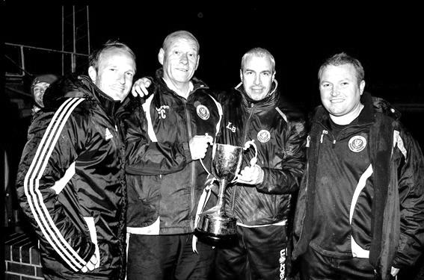
Glyn has been in charge for 172 competitive matches, including today’s match at Godalming Town, and in that time won 46% of his matches in charge; an impressive record. However, the loss of a substantial number of players this year were always going to make success more difficult this season and we have obviously not been able to rise from the foot of the table. As a club that prides itself on its stability and loyalty, both the Manager and Club Committee have tried to solve the issues that we faced this season, but without success.

We can announce that we have no plans to advertise the position and our current Coach Neil Grant will become our Caretaker Manager with effect from Tuesday’s Surrey Senior Cup tie at home to Merstham. He will be given every opportunity over the remainder of this season to stake his claim to the Manager’s position. We hope that supporters will attend our remaining matches in numbers to support him in this role.

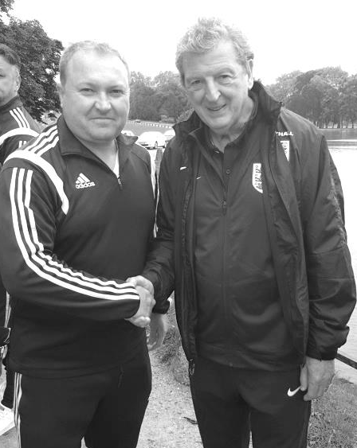
We understand that Glyn is to take a bit of time off and whether or not he returns to Management, we wish him all the best for the future. He will always be welcome at our matches.

Our Chairman – Pete Beddoe
It is with regret that Glyn resigned as our Manager after the Godalming Town match last Saturday. He bowed out with a well-deserved win and clearly used all his skills to motivate the players.

This brought to an end a very successful career with us which started in 2011 as an Assistant to Lyndon Buckwell. Other highlights during his time were two top four finishes in the Combined Counties League and an appearance in the League Cup Final last May.

This season started unfortunately, which I don't need to repeat again but Glyn has striven throughout the season, in these very difficult circumstances to get out us out of trouble. In this respect he has continued to fulfil all his duties in his usual very professional manner.

I personally will miss his excellent company and in particular his dry wit. He has always spoken his mind over any issues and I personally found that very useful. His advice has always been sound and there has always been a frank and direct exchange of views.

As part of our seamless transfer of duties Neil Grant, our present Coach will take the reins of Caretaker Manager from today's match. I ask everyone to give him their full support as he gets accustomed to this new position and to remind everyone that we have to be patient.

Finally, on behalf of everybody associated with the Club we would just like to thank Glyn for all his efforts over the last seven seasons. He has been a pleasure to work with and the difficulties of this season should not make us blind to how well he has done as our Manager. We are sad things have turned out as they have this year and we have lost a very good man from our team and committee. We wish him and his family well for the future and he will always be a welcome visitor to us at Epsom and Ewell.

All the very best Manders in the future; rest assured you will be missed and those extra cuppas just before matches!

Recent Results and Fixtures
Combined Counties League – Saturday 16th December
Bedfont Sports | 3-2 | Sutton Common Rovers
Farnham Town | 1-2 | Hanworth Villa
Guildford City | 1-2 | Redhill
Horley Town | 1-1 | Knaphill
Spelthorne Sports | 1-0 | Balham
Walton & Hersham | 0-0 | Camberley Town
Combined Counties League – Tuesday 19th December
Walton & Hersham | 1-1 | AFC Hayes
Combined Counties League – Saturday 23rd December
Abbey Rangers | 1-1 | Spelthorne Sports
Balham | 1-1 | Guildford City
CB Hounslow United | 0-1 | Banstead Athletic
Chertsey Town | 1-2 | Sutton Common Rovers
Farnham Town | 0-2 | AFC Hayes
Godalming Town | 2-1 | North Greenford United
Hanworth Villa | 1-3 | Bedfont Sports
Horley Town | 3-2 | Epsom & Ewell
Knaphill | 1-1 | Camberley Town
Redhill | 0-2 | Westfield
Combined Counties League – Saturday 30th December
AFC Hayes | 1-3 | Redhill
Bedfont Sports | 1-0 | Farnham Town
Camberley Town | 0-0 | Godalming Town
Epsom & Ewell | 0-2 | Walton & Hersham
Guildford City | 4-3 | CB Hounslow United
Sutton Common Rovers | 3-1 | Hanworth Villa
F.A. Vase Fourth Round – Saturday 6th January
Horley Town | 1-2 | Chichester City
Combined Counties League – Saturday 6th January
Balham | ABANDONED 3-0 | North Greenford United
Camberley Town | 3-0 | Colliers Wood United
CB Hounslow United | 4-3 | AFC Hayes
Chertsey Town | 7-1 | Banstead Athletic
Farnham Town | 1-2 | Westfield
Hanworth Villa | 1-1 | Spelthorne Sports
Knaphill | 2-1 | Bedfont Sports
Redhill | 3-0 | Epsom & Ewell
Recent Results and Fixtures
Combined Counties League – Saturday 6th January 2018
Sutton Common Rovers | 3-1 | Guildford City
Walton & Hersham | 3-1 | Godalming Town
Surrey Senior Cup – Tuesday 9th January 2018
Farnham Town | 0-3 | Metropolitan Police
Westfield | 2-3 | Colliers Wood United
Combined Counties League – Saturday 13th January 2018
AFC Hayes | p-p | Colliers Wood United
Balham | 2-1 | Chertsey Town
Bedfont Sports | 4-2 | Guildford City
CB Hounslow United | 1-0 | Sutton Common Rovers
Godalming Town | 1-2 | Epsom & Ewell
Hanworth Villa | 0-2 | Walton & Hersham
Horley Town | 1-1 | Farnham Town
North Greenford United | 4-1 | Knaphill
Redhill | 1-1 | Camberley Town
Spelthorne Sports | 1-0 | Banstead Athletic
Westfield | 3-0 | Abbey Rangers
Surrey Senior Cup – Tuesday 16th January 2018
Epsom & Ewell | V | Merstham
Combined Counties League – Tuesday 16th January 2018
Walton & Hersham | V | Knaphill
Combined Counties League – Wednesday 17th January 2018
Colliers Wood United | V | Godalming Town
Combined Counties League – Saturday 20th January 2018
Banstead Athletic | V | Sutton Common Rovers
Bedfont Sports | V | Spelthorne Sports
Camberley Town | V | Hanworth Villa
Chertsey Town | V | Knaphill
Colliers Wood United | V | Abbey Rangers
Epsom & Ewell | V | Balham
Farnham Town | V | Godalming Town
Guildford City | V | Walton & Hersham
North Greenford United | V | Horley Town
Redhill | V | CB Hounslow United
Westfield | V | AFC Hayes
Combined Counties League – Tuesday 23rd January 2018
Epsom & Ewell | V | Abbey Rangers

From behind the goal
Horley Town 3-2 Epsom & Ewell
Combined Counties League - Premier Division - Saturday 23rd December 2017

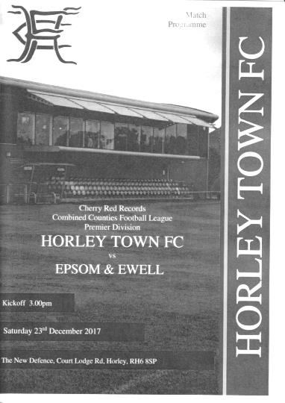
Horley complete rare double over Salts

Over the last forty-five years Epsom and Horley have met in League action with the results mostly going our way. However, this was only the second time, following 2011/12 when we were at Merstham, that Horley have won both matches. As with the previous meeting in September, the score finished 3-2 in their favour but in reality, on neither occasion were we quite good enough to deserve a draw.

In terms of personnel we were missing a host of players from the previous defeat at Westfield two weeks previously as Conor Young, Joshua Burrowes, Adam Heagney and Shaun Masterson were all absent. Fortunately, Liam Roberts returned from suspension and Scott Murphy returned from injury, while Rob Hendry added to our attacking options, while in goal was Mohammed Mustafa Mohammed from Leatherhead.

Yet again though we conceded early, in the 6th minute to a clever one-two between Adam Grant and Leyton Regan which resulted in the latter forcing a save from our debutant keeper, who was unlucky to see the ball bounce straight back to the same player who finished off easily. Whilst the home team provided moments of concern though, we were equally creative in the first half. Impressive left winger Liam Roberts got past Tate Greenaway and arrowed in on goal, only to cut back onto his right foot, at which point he was robbed by the recovering defender. Once our winger improves his decision making, he will be a really good player.

Hendry then sent a dangerous ball across the face of the Horley goal just beyond the incoming Ashley Thompson, before Lloyd Connelly headed a corner over from close range. In response an unfortunate bounce sent Horley through on the left but a deep cross was headed away by Sean White just in front of a few players coming in. It was then their turn to send a ball across the face of our goal shortly after this, but at the other end, good work between Murphy and Hendry resulted in our striker firing wide from just ten yards out just before the break.

We would have gone in at half time fairly pleased with our efforts against a team that remain in the last 32 of the F.A. Vase. However, within four minutes of the second half starting we were two-nil down. Regan produced a good run down the right and as he cut inside our man he was clearly tugged and the penalty awarded, which was

dispatched by Ryan Smith. Things got a bit scary for the next ten minutes as Horley upped their game but couldn't find the target. They had a free header at the far post that went wide just after their goal, and then in the 55th minute they broke through but Mohammed stood up well and the shot went just wide. Unfortunately our keeper then produced a poor clearance which was fed back in, although again the eventual shot was just wide. If our keeper's right hand post had been a yard wider we would have been 5-0 down!

Roberts was unfortunate to pick up a booking for an alleged dive, as he beat his man before going down, although admittedly there was little contact and I was expecting a corner. However, we changed our shape with a quarter of the match remaining as Germaine Jeannoel replaced Ben Dyson and we reverted to a 4-4-2 which gave us more to aim at up front as we chased the game.

In the 73rd minute we pulled a goal back and it must be said it was a strange one. Roberts did well down the left before cutting in and seeing his shot blocked. His second effort was also blocked but the ball looped up and was headed back to goal by a defender, although keeper George Hyde made a hash of it as it squirmed past him and headed towards goal with Jeannoel getting there inches before the line to register his first goal for the club and to reprieve the defender from the credit of an own goal.

Five minutes later there was another "almost" own goal as Smith sliced a Hendry corner down into the ground and up towards the top corner, but Hyde was able to punch the ball away and in the 85th minute Horley made the game safe when a shot at goal rebounded nicely to Alex Barbary who finished clinically into the bottom corner from eight yards out.

There was still time for our boys to reduce the deficit as Jeannoel cut outside his man and was clipped just inside the area. I had a fairly good view of this one and felt it was a penalty but there wasn't much of an appeal from our players and the Assistant on that side appeared unimpressed. Fortunately for us the referee awarded the spot kick anyway and Hendry kept up his 100% record from 12 yards with another clinical strike in the 93rd minute. There was just time for Hyde to rather stupidly earn a yellow card for throwing the ball away into the corner of the ground before the final whistle blew and we had to accept a narrow defeat, only our third in eighteen visits to Horley.

We are improving and can now compete against many of the teams in this league. However, the facts say that this was our sixth League defeat in a row; a sequence not seen since the 2010/11 season, and one more at home to Walton & Hersham next Saturday would take us back to our 2003/04 relegation season when it happened twice! We now find ourselves nine points adrift of Godalming Town and thirteen points away from the likely safety position of fourth from bottom, following wins for Godalming and AFC Hayes at the weekend.

Epsom and Ewell: Mustafa Mohammed, Endrit Dobraj, Sean White, Calum Kennedy,
Alex McKay (c), Ashley Thompson. Liam Roberts, Scott Murphy, Rob Hendry,
Ben Dyson, Lloyd Connelly

Subs: Germaine Jeannoel for Dyson (67), Corey Mullings for Roberts (79)

From behind the goal
Epsom & Ewell 0-2 Walton & Hersham
Combined Counties League - Premier Division - Saturday 30th December 2017

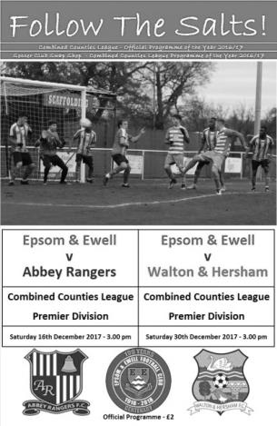
Salts undone by Swans second half double

Our boys fell to a narrow defeat against Walton & Hersham yesterday, despite a hard working performance across the field. Ultimately the visitors had just a little too much for us and two goals in six minutes early in the second half were the difference between the teams. Although the result was a fair one, the first half was very even and if we had taken our chances then we may have taken something from this match against one of the top four in our League.

And strangely enough after much of the season worrying about the midfield and defence, it is up front that we are beginning to struggle. Defensively we looked fairly solid in this match with right back Noah Stew-Lewis looking to have potential in his first start for the club following a brief cameo at Westfield and with Adam Heagney playing alongside Alex McKay at the back the situation appears to be improving. However, keeping a clean sheet is still a massive ask right now against teams with the firepower of a Walton & Hersham team that scored nine at Banstead Athletic not that long ago and we have to contribute at the other end if we are to pick up any more points in our difficult battle against relegation. We badly missed Rob Hendry and Liam Roberts on this occasion as we recorded our seventh straight League loss for the first time since 2003/04.

The game started fairly evenly on an almost tropical afternoon at High Road and in the opening minutes, Germaine Jeannoel made space on the right but his low cross to Lloyd Connelly was cut out by Brendan Norris in the Walton goal. In return Chris Onoufriou saw his shot cleared off the line by Sean White in the ninth minute. Connelly thumped a shot goalwards from just over twenty yards but was unfortunate to pick out Norris from that range when either side of him might have proved interesting, while White put Norris under pressure shortly afterwards and the keeper was only able to half clear the danger, but as the ball was fed in deep from the left wing the visiting keeper was just able to recover in time to make the catch at full stretch.

A good move down the right initiated by Stew-Lewis found Ben Dyson whose ball inside found Connelly in a dangerous position. He was clattered into on the edge of the area but an advantage was played, although we wasted it by curling a cross straight over the top of the goal. Maybe we should have had the free kick but I'm all for referees playing the advantage where possible and we just didn't take advantage of it on this occasion.

Of course the opposition had opportunities also with Abdeen Abdul looking particularly threatening and his good turn and shot was blocked for a corner which resulted in a low drive from former Salt Howard Newton that Mohammed Mustafa Mohammed was down smartly to save in just in front of the goal. Our keeper was in action again soon after this to save another Abdul strike but at the other end a deep free kick found Connelly at the back

post who tried to head the ball back to Jeannoel, but his contact sent the ball bouncing down and then up, so the latter was only able to manage a looping header which was cleared by the Walton defence.

However, the visitors were beginning to press us back a little more and we were a little lucky when we let a long goal kick from Norris straight through but Florent Bojaj struck his shot high and wide from inside the area. Mohammed had to punch another corner clear before Stew-Lewis made a fine last moment challenge as they threatened to get through on goal. Despite the pressure we then had the best opportunity of the half when White's persistence in chasing a ball resulted in Norris coming to the edge of his area but striking the ball against a team mate and falling kindly for Jeannoel, but from just eight yards out he sent the ball flying well over the bar.

The half ended with a couple of near misses for the visitors, one coming from a short corner that was then fired into the near post and cleared before Billy Jeffreys was put through on goal with a good header but took his shot early and fired well over the bar. This pattern continued in the second half with similar finishing results before the Swans took the lead in the 54th minute when we lost the ball in defence to Athan Smith-Joseph who then fired a shot from 15 yards that appeared to go through Mohammed and into the net. This was unlucky for our new keeper, but he redeemed himself with two fine saves shortly after this.

But in between those chances came our best one of the match as Dyson made good progress on the right and delivered a ball straight to Jeannoel in space around the penalty spot. With hopes of an instant equaliser amongst the expectant crowd though, our striker delayed his shot and by the time he finally struck at goal he had been forced wider and his shot came back off the foot of the post. Dan Rose was high and wide with his follow up from just inside the area, but it transpired shortly afterwards that he had just previously injured his hamstring and he was replaced by Shaun Masterson almost immediately. One injury rapidly became two as Ben Franklin, only just returning from a back injury aggravated at Whitstable Town was trodden on and there was a lot of swelling. He was then replaced by Corey Mullings less than two minutes after Rose had departed.

This led to a reshuffle with White dropping back to cover Franklin's left back role and Connelly moving out to the left to accommodate Mullings and whether this had a bearing or not, we'll never know, but within a minute we were two-nil down as a shot came in from the left wing and whilst Mohammed did well to get down to make the save, Abdul reacted first to knock the loose ball in from close range as the clock reached the hour mark.

The final half of the match contained little of note. We pushed to try and get back into the match but the visitors held firm, although it should also be noted that they rarely looked like adding to their two goal lead. This was an improved performance against one of the better teams in the league and although the task of survival looks very challenging this season, we are beginning to see the nucleus of a team forming that could get us straight back, should the worst happen. It's something that regrettably we need to preparing for, both on and off the field.

Epsom and Ewell: Mustafa Mohammed, Noah Stew-Lewis, Ben Franklin,
Adam Heagney, Alex McKay ©, Kane Grandison, Sean White, Dan Rose,
Germaine Jeannoel, Lloyd Connelly, Ben Dyson

Subs: Shaun Masterson for Rose (57), Corey Mullings for Franklin (59)

Club Records - 16th January
Date | Day | Competition |  | Opponents |  | Scorers
16/01/32 | Sat | Amateur Cup 2 | A | Wycombe Wanderers | 2-7 | T.Dunne, R.Marlow
16/01/37 | Sat | London League | H | Eton Manor | 3-5 | H.Pullen, E.George, J.Jones (pen)
16/01/54 | Sat | Corinthian League | A | Slough Town | 1-5 | B.Wiles
16/01/60 | Sat | Corinthian League | H | Dagenham | 4-2 | S.Law, F.Vernon, V.Jones, N.Dearlove
16/01/65 | Sat | Athenian League 1 | H | Wembley | 2-1 | B.Mackay, o.g.
16/01/71 | Sat | Athenian League 2 | H | Eastbourne | 1-2 | K.Ward
16/01/79 | Tue | Isthmian League 1 | A | Bromley | 0-3
16/01/82 | Sat | F.A. Trophy 3q 2nd replay | A | Gravesend & Northfleet United | 1-0 | T.Tuite
16/01/88 | Sat | Isthmian League 2s | A | Harefield United | 2-1 | M.Elliott, S.Flack
16/01/93 | Sat | Isthmian League 3 | A | Camberley Town | 1-0 | R.Purvis
16/01/10 | Sat | F.A. Vase 4 | A | Long Buckby | 2-3 | K.Hough (pen), R.Burns
Historical Decades
Date | Day | Competition |  | Opponents |  | Scorers
90 years ago – Epsom Town F.C.
14/01/28 | Sat | London League | H | Bostall Heath | 10-3 | R.Marlow (6), F.Watts (3), J.Parr
80 years ago – Epsom F.C.
15/01/38 | Sat | London League | A | Wandsworth United | 2-1 | G.Collins, J.Jones
70 years ago – Epsom F.C.
24/01/48 | Sat | London League | A | Edmonton Borough | 1-7 | T.Rochester
60 years ago – Epsom F.C.
18/01/58 | Sat | Surrey Senior Cup QF | H | Woking | 2-4 | J.Sorensen, J.Bangs
50 years ago – Epsom & Ewell F.C.
06/01/68 | Sat | Athenian League 2 | A | Lewes | 0-10
40 years ago – Epsom & Ewell F.C.
14/01/78 | Sat | Isthmian League 2 | H | Rainham Town | 0-1
30 years ago – Epsom & Ewell F.C.
16/01/88 | Sat | Isthmian League 2s | A | Harefield United | 2-1 | M.Elliott, S.Flack
20 years ago – Epsom & Ewell F.C.
13/01/98 | Tue | Associate Members Trophy 3 | H | Windsor & Eton | 4-1 | A.Boxall (2), A.Rawlinson, K.Webb
10 years ago – Epsom & Ewell F.C.
12/01/08 | Sat | Combined Counties Premier Division | A | North Greenford United | 1-1 | K.Hough

History Corner – 16th January
90 years ago this week we met Bostall Heath for the very first time at West Street, determined to make up for a poor 3-0 defeat earlier in the season; our first in the London League. It’s fair to say that we did that with a 10-3 victory, even though we were only 2-1 up at half time! Reg Marlow set a new club scoring record that has been equalled since, but never surpassed with six goals and Fred Watts also scored a hat trick as we surged to the top of the League.

86 years ago today we visited Loakes Park, the famous old home of the Amateur Cup holders Wycombe Wanderers, who had defeated Hayes in 1931 to lift the trophy for what would be the only time in their history. This match was in the last 32 of the competition, the furthest we had ever been, and had earned the right by defeating another well-known club, Ipswich Town 4-2 at Portman Road. However, we were missing a couple of key players this day and were not able to have a proper go at them with a full strength side and in front of 7,000 spectators we were defeated 7-2. Never again would we reach this stage of the competition, although we did get another opportunity to go to Loakes Park in August of 1984 while both were members of the Isthmian League Premier Division, securing a goalless draw that balmy Tuesday evening.

60 years ago this week we hosted Woking in a Surrey Senior Cup match as our reward for defeating Sutton United in the previous round. Woking were far too strong and beat us 4-2, although it should be remembered that they would go on to win the Amateur Cup at Wembley Stadium just three months later with a comprehensive 3-0 victory over Ilford.

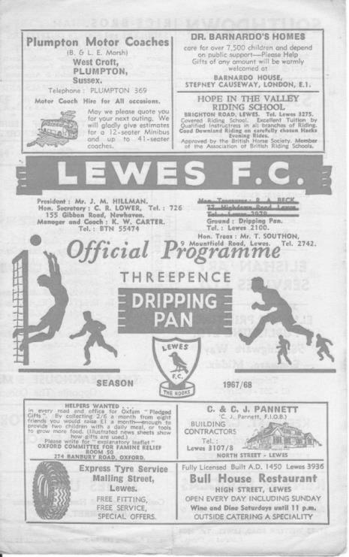
50 years ago this week we visited Lewes for an Athenian League match and were thrashed 10-0. Newstead scored a hat trick for them this day, something he would repeat there in a 5-1 win on New Year’s Day 1977. This defeat remains our second worst in club history. (see programme pictured) We’ll find out about the worst one in a few weeks.

36 years ago today a Tommy Tuite goal was enough for our boys to triumph over Alliance Premier League Gravesend and Northfleet at Stonebridge Road in a second replay of a Third Qualifying Round F.A. Trophy tie. This win earned us a trip to Cheltenham Town who we would also defeat, going on to host the famous Altrincham!

30 years ago today we visited Harefield United for the first ever time and had a tortuous journey in the fog. It was little better at the ground but Matt Elliott put us ahead and although the home side equalised, a shout from behind our goal in the dying seconds told you that Steve Flack had scored a late winner! I recall being stood on the halfway line there and yet I couldn’t see either goal!

8 years ago today we made one of the longest journeys in club history as we travelled to Northamptonshire for a last 32 match with Long Buckby and led early in the match after another nerveless Kyle Hough penalty. However, they weren’t a bad team either and were 3-1 up by the half. Although Robbie Burns reduced the arrears we were unable to force extra time in a nervy final few minutes. It was the fourth and most recent time we had reached this stage.

Above and Below
Ryman League Division One South Table
incl Saturday 13th January | P | W | D | L | F | A | Pts | GD
Lewes | 29 | 19 | 6 | 4 | 58 | 23 | 63 | +35
Cray Wanderers | 29 | 17 | 11 | 1 | 68 | 22 | 62 | +46
Greenwich Borough | 30 | 16 | 10 | 4 | 62 | 28 | 58 | +34
Carshalton Athletic | 29 | 17 | 7 | 5 | 58 | 39 | 58 | +19
Corinthian-Casuals | 30 | 17 | 6 | 7 | 60 | 32 | 57 | +28
Walton Casuals | 30 | 16 | 8 | 6 | 62 | 35 | 56 | +27
Phoenix Sports | 30 | 15 | 5 | 10 | 51 | 36 | 50 | +15
Hythe Town | 29 | 13 | 7 | 9 | 49 | 40 | 46 | +9
South Park | 25 | 13 | 3 | 9 | 50 | 40 | 42 | +10
Sittingbourne | 29 | 12 | 6 | 11 | 46 | 42 | 42 | +4
Horsham | 30 | 12 | 6 | 12 | 45 | 52 | 42 | -7
Hastings United | 29 | 11 | 8 | 10 | 50 | 49 | 41 | +1
Whyteleafe | 29 | 10 | 10 | 9 | 45 | 43 | 40 | +2
Thamesmead Town | 27 | 10 | 7 | 10 | 57 | 53 | 37 | +4
Herne Bay | 28 | 11 | 3 | 14 | 49 | 58 | 36 | -9
Faversham Town | 30 | 9 | 6 | 15 | 40 | 50 | 33 | -10
Chipstead | 29 | 8 | 8 | 13 | 44 | 49 | 32 | -5
Ramsgate | 29 | 8 | 7 | 14 | 44 | 59 | 31 | -15
VCD Athletic | 29 | 9 | 2 | 18 | 46 | 62 | 29 | -16
Guernsey | 28 | 8 | 3 | 17 | 40 | 66 | 27 | -26
East Grinstead Town | 29 | 6 | 6 | 17 | 40 | 73 | 24 | -33
Ashford United | 29 | 6 | 5 | 18 | 34 | 68 | 23 | -34
Molesey (-3) | 28 | 5 | 7 | 16 | 38 | 62 | 19 | -24
Shoreham (-6) | 28 | 2 | 5 | 21 | 27 | 82 | 5 | -55
Since our last review Lewes have been reeled in a little by the chasing pack and by all accounts are fortunate to still be top as I read that Chipstead battered them on Saturday, only to concede the only goal two minutes from time. Still, you need a bit of luck sometimes and it usually evens out. I recall Lewes missing out on promotion by a point twenty odd years ago, all because of a strange refereeing decision where we were denied a retake of a penalty that ultimately cost us a win against Cheshunt which gave them the point they required to finish above the Sussex side!

Cray Wanderers are the club in best form and are right on their heels now, winning 1-0 in Guernsey on Saturday, always a tough place to go. Behind them are Greenwich Borough, despite the shock departure of their Manager in the last seven days and Carshalton Athletic are back up and challenging again after a couple of average seasons. Below them it’s a Casual affair with both Walton Casuals and Corinthian Casuals looking like they will be the other top six finishers.

Although there is still a third of the season to play, Phoenix Sports in seventh place have plenty of ground to make up on those six with maybe only South Park in a better position with many games in hand, largely due to a number of waterlogged pitches. They have recently announced plans for an artificial surface at Whitehall Lane and this certainly appears to represent a good move.

At the other end, Shoreham remain well adrift and are surely preparing for a return to the Sussex League, while our main concerns Molesey look as though they will survive with just one club going down this season. In our position we cannot afford to have a team in our catchment area dropping down from Step Four, so it is vital that someone else finishes at the bottom this season.

Combined Counties League Division One Table
incl Saturday 13th January | P | W | D | L | F | A | Pts | GD
Worcester Park | 21 | 17 | 2 | 2 | 83 | 30 | 53 | +53
Sheerwater | 23 | 14 | 5 | 4 | 66 | 37 | 47 | +29
Cobham | 19 | 13 | 3 | 3 | 60 | 22 | 42 | +38
Badshot Lea | 18 | 13 | 2 | 3 | 52 | 29 | 41 | +23
Staines Lammas | 19 | 12 | 4 | 3 | 52 | 25 | 40 | +27
Eversley & California | 22 | 13 | 1 | 8 | 65 | 48 | 40 | +17
Raynes Park Vale | 20 | 13 | 0 | 7 | 55 | 39 | 39 | +16
AC London | 21 | 13 | 0 | 8 | 48 | 33 | 39 | +15
Frimley Green | 20 | 10 | 5 | 5 | 45 | 33 | 35 | +12
Ash United | 21 | 9 | 2 | 10 | 45 | 55 | 29 | -10
FC Deportivo Galicia | 19 | 7 | 4 | 8 | 44 | 42 | 25 | +2
Farleigh Rovers | 18 | 6 | 3 | 9 | 36 | 49 | 20 | -13
Chessington & Hook United | 21 | 6 | 2 | 13 | 51 | 65 | 20 | -14
Fleet Spurs | 21 | 6 | 2 | 13 | 43 | 64 | 20 | -21
Kensington Borough | 18 | 5 | 2 | 11 | 32 | 47 | 17 | -15
South Park Reserves | 18 | 3 | 4 | 11 | 28 | 54 | 13 | -26
Bedfont & Feltham | 22 | 3 | 2 | 17 | 33 | 69 | 11 | -36
Cove | 21 | 2 | 3 | 16 | 22 | 66 | 9 | -44
Bagshot | 20 | 3 | 0 | 17 | 24 | 77 | 9 | -53
It is inevitable to avoid casting an eye over the teams currently below us this season.

Whilst our season may not be exactly hitting the heights, circumstances elsewhere are really helping us, in the event we could somehow get ourselves off the bottom.

I referred earlier to Shoreham being almost certain to drop, and assuming that we promote two from our own division, then it would be a straight three up, three down situation between our division and this one. However, the top two clubs Worcester Park and Sheerwater are not eligible for promotion. In fact, both are to be relegated at the end of the season as they do not currently meet the Step Six guidelines and the F.A. reorganisation will presumably place them down in the Surrey Elite League at this rate.

Now, whether they are relegated or not isn’t the issue for us; the really important part from our perspective is whether they would block other teams from promotion, which would mean that fewer clubs from our division could be relegated!

Whether Sheerwater (or even Staines Lammas who have games in hand but also face relegation) finish in the top three at the end of the season is of course still up for debate as Cobham, Raynes Park Vale and Badshot Lea all are well in the hunt, but Worcester Park seem certain for a promotion place, so if one of those other non-promotable clubs finish in the top three also, then only one club would probably go down. If I’m honest, it still looks like two teams will drop from our division and this means we would need to finish above two other teams to survive. In fairness though, if we are able to bridge the gap between us and Godalming Town, then it’s a much smaller jump to the rest.

2

Surrey Senior Cup Review
Tonight is our 208th Surrey Senior Cup tie. Over that period we have Won 99, Drawn 21 and Lost 86 with one match abandoned. Our goals in that time are F468 A402. It is also our 106th home tie with 92 being played away from home and ten being at neutral venues. Technically we won our 100th match in the competition last November, but because it was won on penalties, it goes in the club records rightly or wrongly as a draw!

Our very first Surrey Senior Cup tie was played at Krooner Park, when we defeated Camberley & Yorktown as they were then known by three goals to one on 18th October 1924. We trailed at half time, but two goals from Reg Marlow and the other from Tom Kirk saw us through. A win at Egham gave us a home tie with Weybridge in the first round, but we surprisingly lost this 2-1 at home to end our first County Cup run.

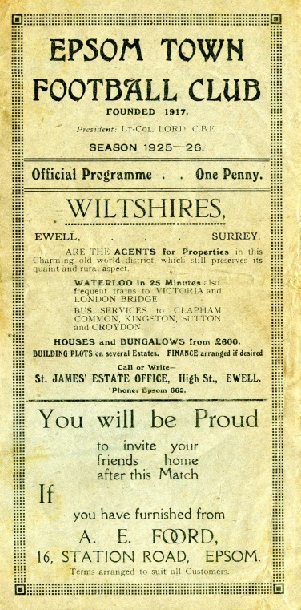
In 1925/26 we started our run with a 3-2 win over Godalming and took revenge on Weybridge by a goal to nil in the next round. This earned us a big match at home to Athenian League Summerstown, who were having a wretched season at the foot of their table, yet they were still two levels above us, and defeated us 4-2 at West Street. (see programme right) The following year was a marathon, as we played six matches but still went out in the first round. We required two replays to dispose of Carshalton Athletic, but minus flu victim Reg Marlow (who was in the middle of his run of five hat tricks in five consecutive matches) we crashed 3-8 at home to Woking.

Summerstown again ended the run 5-1 in the first round in their final season at their Earlsfield Road ground after two wins over Leyland Motors and Aquarius, the Water Board side from Honor Oak, but the 1928/29 season would prove to be the most memorable to date. It didn’t start auspiciously as we were held 0-0 at West Street by the Westminster Bank. We won the replay before knocking out Isthmian League giants Casuals 3-1 at West Street, but the best was yet to come as we humbled Wimbledon 4-1 at Kingstonian’s old Richmond Road ground in the Semi-Final.

The Final ended disappointingly, in front of 4,600 at Guildford City’s Josephs Road ground, we led Redhill at half time with a Bronk Challis goal, but three goals early in the second half changed the match, and a late Bob Earl consolation was not enough as the Lobsters won their first County Cup.

The 1929/30 season was the first time that the Town lost their opening match, away to Tooting Town by four goals to two, but the next season we went all the way to the Quarter-Finals again, by virtue of replay wins over Camberley & Yorktown and Egham. We then earned a trip to Dulwich Hamlet’s old Champion Hill ground, and I mean their first one, not the enormous one that only people over the age of 35 can remember, but the one before that, which was actually alongside the second ground, behind the big terrace.

In front of 5,000 we dominated the game, despite only winning 3-2 (see programme left) but we have never win at Dulwich since. Mitcham Wanderers ended that year’s run 2-1 at West Street.

For the 1931/32 season the Blues were finally awarded an exemption to the First Round, or last 16, along with the big guns in the County. A Reg Marlow hat trick saw us past qualifiers Wills Sports by 6-2 before Kingstonian made their first visit to West Street since they were present at the opening of the ground, and eased to a 4-1 win in a match that was all over as a contest by half time with the visitors being three goals to the good.

In the thirties we were a very good side. However you wouldn’t have known this from our County Cup performances as we lost in the opening round for four years in a row to, Tooting & Mitcham, Dulwich again, Nunhead and in 1935/36 3-4 at home to Met Police.

So in 1936/37 it was back to the qualifiers, although Banstead Hospital knocked us out in extra time in the final qualifying round. This was a pity as we would have faced our tenants Ewell & Stoneleigh in the next round, but Banstead knocked them out too and actually went all the way to the Semi-Final.
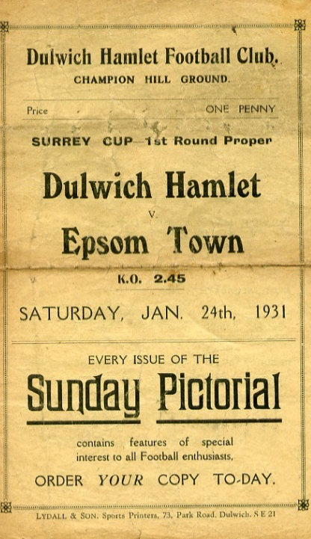
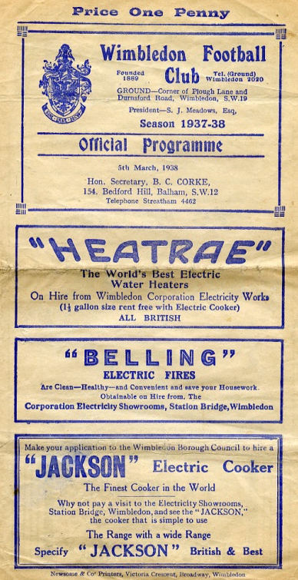
Despite going out in the qualifying rounds we received an exemption to the First Round again for 1937/38. We took full advantage, defeating Met Police 4-1 and Isthmian League Nunhead by five goals to one to reach the Semi-Final against the mighty Dulwich Hamlet. The match was played at the much-missed Plough Lane, Wimbledon see programme right), where goals from Rochester and Bruce ensured a replay at Richmond Road. There we were defeated 3-2 in extra time in a match where Jackie Pullen missed a sitter at the end of normal time with the score 1-1.

The press called it “a tragedy”, and despite Pullen netting in the extra period, we were unable to force another equaliser. It is worth noting that the Hamlet had won the previous year’s competition without conceding a goal, and were looking at repeating this achievement until they came up against us. (see programmes right and over page).

Tooting & Mitcham defeated us 3-2 at Sandy Lane in the opening round of the final pre-war competition During the war, the Cup was played for in 1939/40 by Epsom Town (losing in the Quarter Final to Nunhead), who continued through the war at West Street, before it was held in abeyance for a few years. It returned in 1943 with just nine teams entering, but Epsom Town reached the final, losing to

Tooting & Mitcham 3-1 at Sandy Lane in front of over 5,000 spectators (see programme below). However, the club would never win another match in the competition, losing over two legs to the Magpies again the next year and to Vickers Armstrong after a replay in their final season of 1945/46.

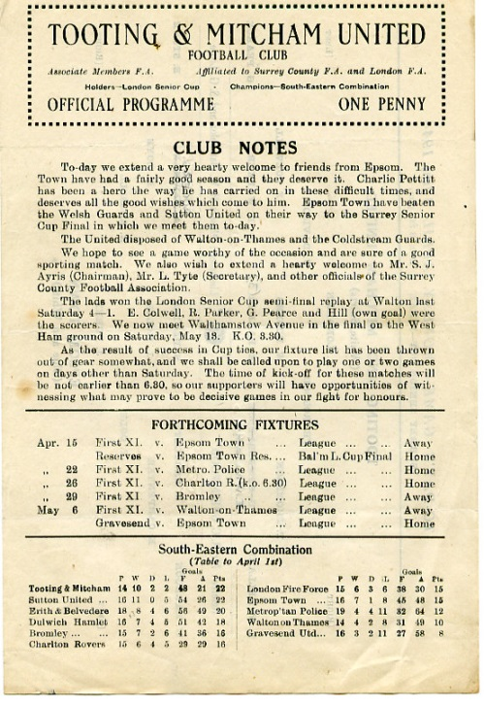
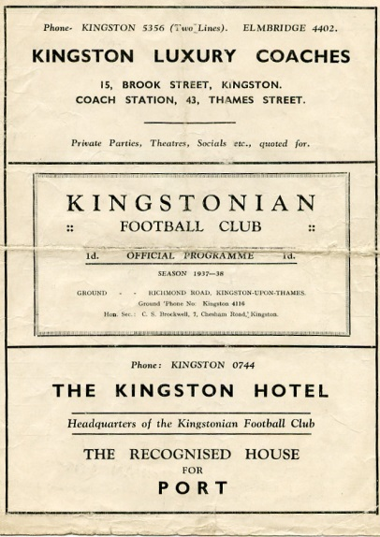
In that season Epsom F.C. reformed and defeated Carshalton Athletic 7-3 but were thrashed 6-0 in the Quarter-Final by the recently formed Corinthian Casuals at Richmond Road, where they ground shared with Kingstonian for a spell after the war. Despite reaching the last eight, we then had to play a qualifying round in 1946/47, but crashed out at home to Devas Institute. Oddly though we were back amongst the exempted clubs the following season, but it made no difference as we lost 3-2 at home to Corinthian Casuals again.

In 1948/49 we qualified past Devas (4-0) and Byfleet (6-1) but were defeated by the rising Walton & Hersham team 5-0 in front of 3,000 at Stompond Lane. The following season we were again exempt but Dulwich came away from West Street with a 6-0 win which put us back down amongst the qualifiers again!

It was a bit of a yo-yo situation really. We were obviously right on the edge of being one of the best eight clubs in the County, as we would rarely get beaten in the qualifiers.

McLaren Sports and Devas were beaten before we beat Hawkers, the Kingston based works side 6-1. Well, almost! We were nine minutes away from winning before being hit by a massive fog that was so heavy it caused our home Reserve team game to be called off at exactly the same time ten miles away in Epsom, with us leading that match 4-0 at the time. It was an unfortunate day! We played the following week and edged through 4-3 before again being hammered by Corinthian Casuals, this time 7-1 at West Street.

We were facing a regular scenario. Beat a few average teams before coming up against either Casuals or the Hamlet. For the next three years it would be the latter, winning 4-2 and 4-3 at West Street in consecutive seasons. However, the 1953/54 season would see the tables turned for a change.

Firstly, we received another exemption, for reaching the Quarter-Final the year before, and the draw was kind. We defeated Addlestone and Malden Town without conceding, and faced our nemesis in the Semi-Final at Plough Lane, where a Roy Dymott goal was enough to secure a draw

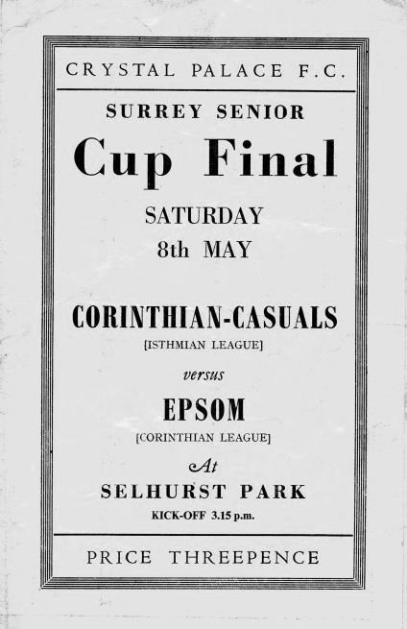
there, just as we had 16 seasons before. This time the replay was at Sandy Lane, where 7,000 witnessed a stunning comeback. We trailed 2-0 with eighteen minutes left, but Gordon Hurst pulled a goal back, and then right on full time as the crowds were beginning to drift away Bill Wiles equalised, with Bobby Avis securing the win with a goal in the second period of extra time. (see programmes above) However, our reward for defeating Dulwich was a Final against Corinthian Casuals! The game was played at Selhurst Park in front of 6,159 and was a let down with our boys conceding once in each half, despite being the better side on the day. (see programme left)

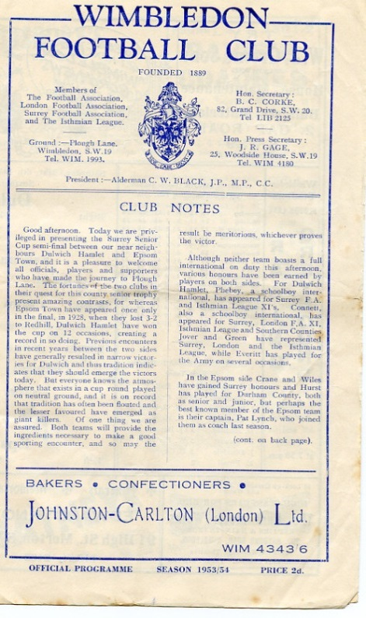
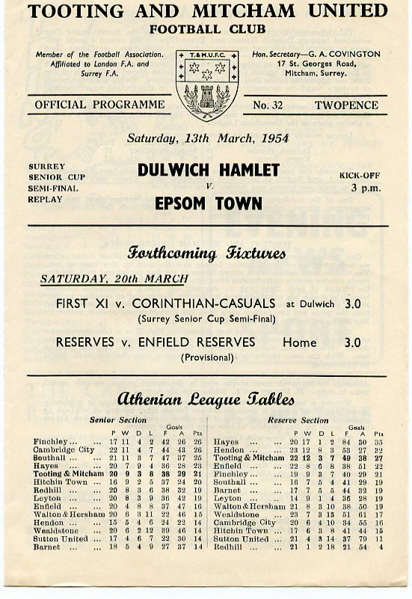
It was Dulwich again in 1954/55 that knocked us out 4-1 and although we edged past Banstead 3-2 on our first visit to Merland Rise, Tooting & Mitcham put us out in 1955/56. The next season was one of our best though, as we battered Kingstonian 5-1 at West Street before then smashing Dulwich Hamlet 5-3 with our free-scoring team that year. However, the semi-final brought an unlucky 2-1 defeat to Wimbledon at Sandy Lane.

It seems downright bizarre that we always seemed to

play the same teams, yet never met Sutton United in this competition until 1957, when Johnny Bangs and Jan Sorensen were the scorers in a 2-0 win at West Street. (see programme right). It would be twenty-four years before we would meet again.

In the meantime our luck was about to change for the worse. Woking defeated us 4-2, and then we crashed 5-1 at Dorking in December 1958. This result sent us back to the qualifiers, where we would remain until 1981. As our fortunes plummeted, we only reached the First Round once in the sixties, when wins over Whyteleafe, Chobham (after a replay, awarded because the pitch there was undersized) and Camberley gave us a home tie against, yes, Dulwich again! The attendance of 608 was the best we’d get until the Vase run of 1974/75 as the visitors won 2-1.

And it was in 1975 that we next reached that stage of the competition, being defeated 3-4 at Addlestone, although at 4-0 down we gave them a fright and this helped when we met and defeated them later that season in the F.A.Vase Quarter-Final.

In 1976/77 we reached the First round again, losing 2-1 at home to Walton & Hersham after a replay. This earned us an exemption to the final qualifying round, ahead of many lower league sides, but not quite up with the big boys yet. Tooting & Mitcham and Egham defeated us in the first round in the next two seasons, with Dorking knocking us out in the qualifiers the next year.

In 1980/81 we had a good side, but no one would have expected what happened next. We opened up with a narrow 2-1 win over Westfield before winning 6-0 at Ash United in the First Round. The Quarter-Final drew us at Walton & Hersham and we got a 1-1 draw there, finishing them off in the replay 4-2. Enter Sutton United, who were having a very good season themselves which would end at Wembley for an F.A.Trophy Final. We held our more illustrious opponents goalless before winning the replay at West Street 3-2. After beating Sutton, Woking held no fears for us, as they were bottom of the Isthmian Premier Division, and we defeated them 2-1 at Sandy Lane to win the cup for the first and so far only time in our history. (see programme left)

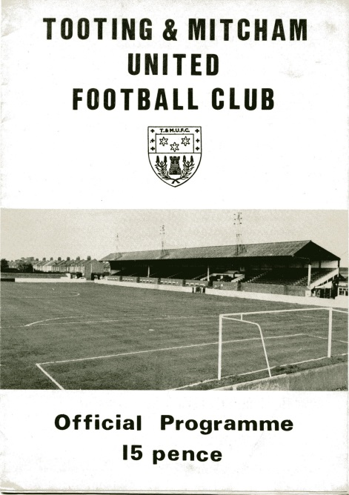
As holders, this had the added benefit of giving us a full exemption again, but despite defeating Tooting & Mitcham and Walton & Hersham, we were robbed on a technicality against Croydon.

Pat O’Connell had left the club, leading to the departure of many of the team and Adrian Hill had no chance to get any new players in as the Surrey F.A. rules stated that a player had to be registered for 28 days before playing in this tie, so we had all sorts of trouble even fielding a side. Leading striker Steve Hill even played in goal for us, despite having a stress fracture in his shin that prevented him taking an outfield role, and Croydon won 4-0, ending our brief hold on the trophy in criminally farcical circumstances.

In January 1983 Sutton United defeated us in the County Cup for the first time ever with a 2-1 win at Gander Green Lane, and the following season the two teams met in the Final, after we had defeated Addlestone & Weybridge (after a replay), Banstead and Croydon, again after a replay. However, we were blown away, losing 4-0, although we were promoted that year.

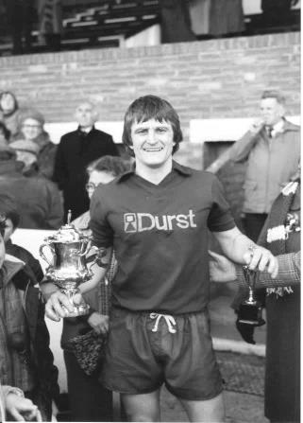
And they did it again the following season with a 4-1 win at West Street after we had held them goalless just two days previously at Sutton. There was a temporary respite in 1985/86 when it was Kingstonian that knocked us out 2-0 at Richmond Road, but it was Sutton again in the Semi-Final of 1986/87 by five clear goals.

We reached the Semi-Final again in 1988/89 but despite holding Carshalton Athletic 2-2 at home, we were harshly defeated 3-0 at Colston Avenue, and three narrow quarter-final defeats in three years followed to Woking, Whyteleafe and Carshalton again.

Since then we have achieved very little in the competition with exception of a Quarter-Final appearance in 2001/02 when we were defeated 3-1 by a Wayne Routledge inspired Crystal Palace, and in 2008/09 when we reached the Semi-Final, aided by an historic and fantastic 3-2 win at Sutton United, plus wins over Horley Town, Redhill and Corinthian Casuals. This gave us the opportunity to visit Step Three side at the time Ashford Town (Middx), but they were too strong for a tired Epsom team and eased through 4-1, despite Robbie Burns equalising to make it interesting for a while.

This 208th fixture could of course be our last in a competition we have graced continuously since 1924. On paper our opponents are likely to be too strong for us and the very real likelihood of relegation this season would bring an end to our entry in the Senior version of the County Cup, instead entering the Surrey Premier Cup. I bet that no teams have won both Cups with their first teams, so maybe this could be a very real target next season if we were to go down.

Left: Our Captain Peter Gaydon lifts the Surrey Senior Cup at Sandy Lane on Easter Monday 1981.

Combined Counties League Premier Division
Opponents All-time Records
inc Saturday  13th January | P | W | D | L | F | A | PPG | GD | Best  Win | Worst  Loss
Abbey Rangers | 4 | 3 | 0 | 1 | 11 | 4 | 2.25 | +7 | 7-1 | 2-3
Sutton Common Rovers | 14 | 9 | 3 | 2 | 30 | 19 | 2.14 | +11 | 4-0 | 0-5
Horley Town | 32 | 21 | 5 | 6 | 71 | 37 | 2.13 | +34 | 6-0 | 1-3
Spelthorne Sports* | 8 | 5 | 2 | 1 | 16 | 11 | 2.13 | +5 | 6-2 | 1-5
Banstead Athletic | 38 | 23 | 7 | 8 | 62 | 38 | 2.00 | +24 | 5-0 | 0-4
Godalming Town | 3 | 2 | 0 | 1 | 4 | 5 | 2.00 | -1 | 2-1 | 0-3
Bedfont Sports | 12 | 7 | 2 | 3 | 21 | 19 | 1.92 | +2 | 5-1 | 0-7
Colliers Wood United | 24 | 14 | 2 | 8 | 47 | 39 | 1.83 | +8 | 4-0 | 0-5
Farnham Town | 17 | 9 | 4 | 4 | 30 | 25 | 1.82 | +5 | 3-0 | 1-4
Guildford City | 19 | 11 | 1 | 7 | 36 | 25 | 1.79 | +11 | 5-1 | 1-5
Knaphill | 9 | 5 | 1 | 3 | 19 | 15 | 1.78 | +4 | 4-0 | 2-6
Westfield | 22 | 12 | 3 | 7 | 43 | 41 | 1.77 | +2 | 6-1 | 0-5
Walton & Hersham | 53 | 25 | 11 | 17 | 105 | 101 | 1.62 | +4 | 8-0 | 1-9
Hanworth Villa | 18 | 8 | 5 | 5 | 39 | 28 | 1.61 | +11 | 5-0 | 1-4
Camberley Town** | 91 | 38 | 23 | 29 | 159 | 126 | 1.52 | +33 | 9-1 | 0-4
Redhill | 35 | 14 | 2 | 19 | 63 | 77 | 1.26 | -14 | 7-2 | 2-8
Chertsey Town | 51 | 19 | 5 | 27 | 77 | 95 | 1.22 | -18 | 3-0 | 0-7
North Greenford United | 13 | 4 | 2 | 7 | 19 | 24 | 1.08 | -5 | 3-0 | 1-4
AFC Hayes | 11 | 2 | 3 | 6 | 18 | 20 | 0.82 | -2 | 7-0 | 0-3
CB Hounslow United | 4 | 1 | 0 | 3 | 6 | 11 | 0.75 | -5 | 2-0 | 1-5
Balham | 1 | 0 | 0 | 1 | 0 | 4 | 0.00 | -4 | x | 0-4
* includes one loss on penalties v Spelthorne and one win on penalties v Sutton Common Rovers
** includes one abandoned match v Camberley

Buildbase F.A. Vase
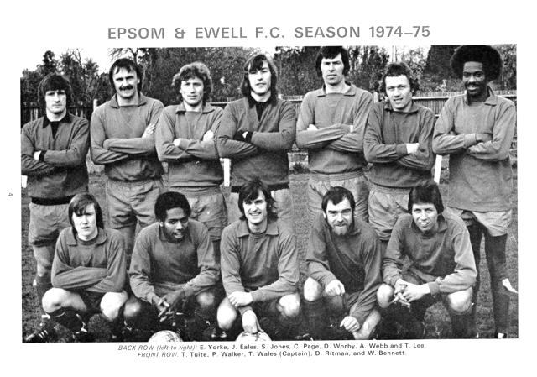

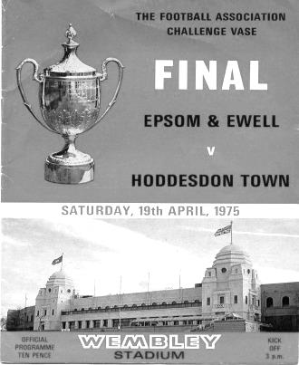
Fourth Round –6th January
Newcastle Benfield | 1-1+ r1-1+ p2-4 | Coleshill Town
Wisbech Town | 1-3 | Bromsgrove Sporting
Cogenhoe United | 2-3 | Wolverhampton SC
Marske United | 5-0 | Hinckley AFC
1874 Northwich | 3-1 | Pontefract Collieries
Stockton Town | 2-1+ | West Auckland Town
Desborough Town | 2-4+ | Stourport Swifts
Melksham Town | 2-1 | Crowborough Athletic
Westfields | 1-4 | Hamble Club
Blackfield & Langley | 3-3+ r1-2 | Bracknell Town
Leighton Town | 5-2+ | Norwich CBS
Newport (IW) | 0-1 | Bradford Town
Eastbourne Town | 1-3 | Windsor
Horley Town | 1-2 | Chichester City
Tring Athletic | 5-1 | Hullbridge Sports
Thatcham Town | 2-1 | Biggleswade
Fifth Round Draw – 3rd February
Wolverhampton SC | V | Leighton Town
Thatcham Town | V | Bromsgrove Sporting
Marske United | V | Bradford Town
Coleshill Town | V | Bracknell Town
1874 Northwich | V | Chichester City
Stockton Town | V | Stourport Swifts
Windsor | V | Hamble Club
Melksham Town | V | Tring Athletic

EL Records Premier Challenge Cup
Quarter-Finals
Godalming Town | 6/2 | Knaphill
Spelthorne Sports | 6/2 | Walton & Hersham
Sutton Common Rovers | 22/1 | Cobham
Worcester Park | 3/2 | Colliers Wood United

Centre page for results

Centre page for results

CCL Premier Division Club Directory
ABBEY RANGERS Telephone: 01932-422962 - Colours: Black & White Stripes/Black/Black
Ground: Addlestone Moor, Addlestone. KT15 2QH

A.F.C. HAYES Telephone: 0208-845-0110 - Colours: Blue and White Stripes/Blue/Blue
Ground: Farm Park, Kingshill Avenue, Hayes. UB4 8DD

BALHAM Telephone: 0208-942 8062 - Colours: White & Black/Black/Black

Ground: Colliers Wood United FC - Wibbandune, Robin Hood Way, Wimbledon. SW20 0AA -

BANSTEAD ATHLETIC Telephone: 01737-350982 - Colours: Amber &Black/Black/Black
Ground: Banstead Athletic, Merland Rise, Tadworth. KT20 5JG

BEDFONT SPORTS Telephone: 0208-831-9067 - Colours: Red & Black Hoops/Black/Red & Black
Ground: Bedfont Sports Club, Hatton Road, Bedfont. TW14 8JA

CAMBERLEY TOWN Telephone: 01276-65392 Colours: Red & White Stripes/Blue/Red
Ground: Krooner Park, Wilton Road, Camberley. GU15 2QW

CB HOUNSLOW UNITED Telephone: 0208-577 -9712 Colours: Green/Black/Green
Ground: CB Hounslow Sports Ground, Green Lane, Hounslow TW4 6DH

CHERTSEY TOWN Telephone: 01932-561774 - Colours: Royal Blue & White Stripes/ Blue/ Blue
Ground: Alwyns Lane, Chertsey. KT16 9DW

COLLIERS WOOD UNITED Telephone: 0208-942 8062 - Colours: Royal Blue/Black/Black
Ground: Wibbandune, Robin Hood Way, Wimbledon. SW20 0AA

EPSOM & EWELL Telephone: 01737-553250 - Colours: Royal Blue & White Hoops/Royal Blue/Royal Blue - Ground: Chipstead FC, High Road, Chipstead. CR5 3SF

FARNHAM TOWN Telephone: 01252-715305 - Colours: - Claret & Sky Blue /White/ Claret & Blue
Ground: Memorial Ground, Babbs Mead, West Street, Farnham. GU9 7DY

GODALMING TOWN Telephone: 01483-417520 - Colours: Yellow/Green/Yellow
Ground: Wey Court, Meadrow, Godalming. GU7 3JE

GUILDFORD CITY Telephone: 01483-443322 - Colours: Red & White Stripes/Black/Black
Ground: The Spectrum, Parkway, Guildford, Surrey. GU1 1UP

HANWORTH VILLA Telephone: 0208-831-9391 - Colours: Red & White Stripes/Black/Black
Ground: Rectory Meadows, Park Road, off Hounslow Road, Hanworth. TW13 6PN

HORLEY TOWN Telephone: 01293-822000 - Colours: Claret & Sky Blue/Claret/Claret
Ground: The New Defence, Anderson Way, Court Lodge Road, Horley. RH6 8SP

KNAPHILL Telephone: 01483-475150 - Colours: Red/Black/Red & Black
Ground: Brookwood Country Park, Redding Way, Lower Guildford Road, Knaphill. GU21 2AY

NORTH GREENFORD UNITED Telephone: 0208 422 8923 - Colours: Royal Blue & White/Royal Blue/Royal Blue - Ground: Berkeley Fields, Berkeley Avenue, Greenford, Middx UB6 0NX

REDHILL Telephone: 01737-762129 - Colours: Red and White Stripes/Red/Red
Ground: Kiln Brow, Three Arch Road, Redhill. RH1 5AG

SPELTHORNE SPORTS Telephone: 01932-961055 - Colours: Navy & Sky Blue/ Blue/ Blue
Ground: Spelthorne Sports Club, 296 Staines Road, Ashford Common, Ashford. TW15 1RY

SUTTON COMMON ROVERS Telephone: 0208-644-4440 - Colours: Yellow/ Yellow / Yellow
Ground: Sutton United FC, Gander Green Lane, Sutton. SM1 2EY

WALTON & HERSHAM Telephone: 01932-245263 - Colours: Red & White Trim/Red/Red
Ground: Stompond Lane, Walton on Thames. KT12 1HF

WESTFIELD Telephone: 01483-771106 - Colours: Yellow/Black/Black
Ground: Woking Park, Kingfield Road, Woking. GU22 9BA

Scouting the Opponent – Merstham
We used to know Merstham quite well as we used Moatside for our home ground for two seasons from 2010-12 before coming to Chipstead. However, since then, their climb has continued. When we last played them in 2007/08 we were both in the Combined Counties League; a level they had not exceeded in their entire existence. While we were there they were an Isthmian League South Division club, but since then they have established themselves as a Premier Division club and recorded an apperance in the First Round Proper of the F.A. Cup, when Oxford United visited!

Moatside is a well appointed, neat and tidy ground these days and they are better supported than they used to be too, so hopefully we will have a decent attendance for our meeting as they take this competition very seriously, having won it a few times frequently. It will be nice to see them again!

Moatside when the entrance was in Albury Road and the pitch was situated 90 degrees from where it is now

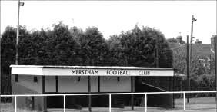

Isthmian League Premier Division
incl Saturday 13th January | P | W | D | L | F | A | Pts | GD
Dulwich Hamlet | 28 | 19 | 5 | 4 | 60 | 27 | 62 | +33
Billericay Town | 22 | 18 | 3 | 1 | 57 | 17 | 57 | +40
Staines Town | 28 | 14 | 7 | 7 | 60 | 40 | 49 | +20
Folkestone Invicta | 27 | 15 | 4 | 8 | 58 | 41 | 49 | +17
Leiston | 28 | 14 | 6 | 8 | 48 | 35 | 48 | +13
Hendon | 25 | 15 | 2 | 8 | 57 | 29 | 47 | +28
Metropolitan Police | 29 | 13 | 7 | 9 | 53 | 47 | 46 | +6
Margate | 26 | 12 | 8 | 6 | 43 | 30 | 44 | +13
Leatherhead | 25 | 14 | 2 | 9 | 34 | 29 | 44 | +5
Wingate & Finchley | 25 | 13 | 3 | 9 | 35 | 33 | 42 | +2
Tonbridge Angels | 27 | 11 | 5 | 11 | 37 | 37 | 38 | 0
Enfield Town | 27 | 9 | 9 | 9 | 45 | 46 | 36 | -1
Brightlingsea Regent | 28 | 10 | 5 | 13 | 48 | 53 | 35 | -5
Thurrock | 29 | 10 | 4 | 15 | 39 | 53 | 34 | -14
Harrow Borough | 30 | 10 | 4 | 16 | 43 | 59 | 34 | -16
Kingstonian | 26 | 10 | 2 | 14 | 34 | 48 | 32 | -14
Dorking Wanderers | 25 | 9 | 4 | 12 | 40 | 45 | 31 | -5
Lowestoft Town | 27 | 9 | 4 | 14 | 35 | 45 | 31 | -10
Merstham | 28 | 7 | 8 | 13 | 42 | 52 | 29 | -10
Harlow Town | 28 | 8 | 3 | 17 | 32 | 58 | 27 | -26
Needham Market | 29 | 6 | 8 | 15 | 42 | 53 | 26 | -11
Worthing | 28 | 6 | 7 | 15 | 40 | 55 | 25 | -15
Tooting & Mitcham United | 28 | 7 | 4 | 17 | 38 | 67 | 25 | -29
Burgess Hill Town | 25 | 5 | 6 | 14 | 36 | 57 | 21 | -21

Merstham F.C. – History
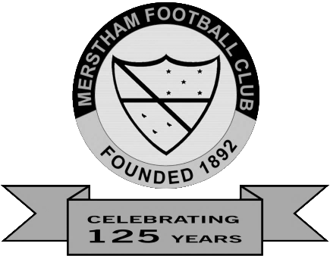
In the early years of Merstham FC, matches were played on a pitch situated at the old Merstham Lime Works known as Limeworks Meadow which was accessed via Jolliffe Road, Lime Works Road or Quarry Dean Lane. At first changing facilities were non-existent and the players had to make do with the hedgerows to shield their modesty. After some time, accommodation was made available at the Jolliffe Arms (now the Vojan Indian Restaurant).

The level of football played in the first five years is unclear. However by 1897 the club were founder members of the Redhill & District League although the Surrey Mirror reports that they ‘opened their first season with a friendly match against Redhill Gas Works’ on Saturday 29th October 1904 having been elected as an affiliate of the Surrey FA in the previous September; so this may only relate to their first match as members of the Surrey FA. It is certain though that they were playing in the Redhill & District League Division Two in the 1905/06 season along with, amongst others, Redhill Gas Works, Holmethorpe, Whyteleafe and Bletchingley. It was not until the early 1920s that the club moved to its present location in Albury Road, although it is also believed that for a period of time around 1911, under the Presidency of Reverend Reginald Woodhouse, the club occupied a ground at ‘The Weir’ adjacent to the existing Merstham Cricket Club ground.

The club’s first major success was winning the league in 1927 and in 1930 added the East Surrey Junior Cup to their trophy cabinet. 1935 and 1936 saw Merstham record a remarkable double by winning the Redhill League Premier Division in consecutive years; a record later repeated in the post World War II years of 1950 and 1951. It was at this time that the decision to apply for intermediate status was taken and Merstham FC was duly accepted into the Eastern Section of the Surrey Intermediate League. The move to the new league could hardly have paid more rapidly a reward, for in the 1952-53 season the club proved their readiness for the test by claiming the title at their first attempt.

Major achievements were also in progress off the field and in 1960, through the devotion and hard work of club officials and members, in partnership with the local authority, the changing room and tearoom were constructed and training lights were erected. This was followed some years later in 1974 by the construction of a small stand with a modest capacity of some 90 people. Although unable to win the league again, Merstham continued to play in the Surrey Intermediate League until they gained senior status in 1964 and joined the Surrey Senior League. In a fourteen year phase in the Surrey Senior League Merstham managed to win the title only once in the 1971/72 season. In 1978 they again switched leagues joining the London Spartan League and attaining a creditable third in their first two seasons. Those first two seasons proved to be amongst the club’s best as in addition to their pleasing league positions they claimed the Surrey Senior Charity Cup and the London Spartan League Challenge Cup in the first season, adding the East Surrey Charities Cup the following year.

By the 1984/85 season Merstham had decided that the travelling involved in the Spartan League was proving too much on the club’s resources and they applied to join the Combined Counties League, partly reformed from the Surrey Senior League. This new league encompassed teams from Surrey, Berkshire, Hampshire and Middlesex. 1984 also saw the completion of the new clubhouse replacing the portable shelter that had been in use since 1975.

Merstham were runners-up in the Combined Counties League in the 1987/88 season and the

following year proved to be the club’s best season in senior football by reaching the fourth round of the FA Vase losing, to Billericay Town at home 2-3 after throwing away a 2-0 lead. They then won the Dan Air Class Elite Cup beating local rivals Chipstead 2-1 after extra time. This came as some consolation as Chipstead had just pipped Merstham to the league title by a single point.

The 1990/91 season saw the erection of floodlights at the Weldon Way ground and an official ‘Floodlight Opener’ against Crystal Palace whose side included the current Middlesbrough United Manager Gareth Southgate. Merstham's defence of the League Cup saw them again reach the final where this time they had to settle for the runners-up spot as Frimley Green defeated a tired Merstham side 1-0, after extra time, in a replay.

The next few seasons saw Merstham generally settle for mid-table anonymity; 1991/92 (14th) 1992/93 (4th), 1993/94 (17th), 1994/95 (15th) and 1995/96 (4th).

The FA Cup of 1996/97 was, historically, Merstham’s biggest defeat when they crashed out in the 1st Qualifying Round at home to Aldershot Town. Aldershot ran riot with an impressive eight goals to which Merstham could only reply with a token one.

The next two years saw some improvement in their fortunes, 11th in 1998/99 and 13th in 1999/2000; after a disastrous start which saw them bottom at Christmas. The 2000/01 season was Merstham's most successful for nearly a decade. They reached the 2nd Qualifying Round of the FA Cup, their best showing, and finished eighth in the league after being in the top six for most of the season.

The 2002/03 season brought AFC Wimbledon into the league and their visit to Merstham attracted 1,582 fans, the club's record home attendance. Unfortunately the visitors won 2-0. A successful application to the FA Stadia Fund enabled the club to build the new changing rooms and add a perimeter fence.

‘Silverware’ returned to Merstham in the 2004/05 season when they beat AFC Guildford (now Guildford City) 3-0 in the final of the Premier Challenge Cup held at Woking FC and they also won the East Surrey Hospitals Charity Cup with a victory over local rivals Redhill. Despite this a poor run of results as the season drew to a close saw them finished in 16th spot in the league.

The 2005/06 was their best all round season for twenty years; Beaten finalists in the Premier Challenge Cup and ESHCC and runners up in the Combined Counties Premier Division. Also Merstham’s regular goalkeeper Colin Harris (now with Corinthian-Casuals) kept an incredible 19 clean sheets in the league making him the league’s top ‘keeper. However disappointment followed when they were denied promotion to the Ryman League because their stand was delivered two weeks late.

Many of the players moved on during the close season all with the good wishes of the club; notably Captain Chris Boulter who joined promoted Godalming Town. For the 2006/07 season manager, Mick Sullivan, along with two new assistants Micky Stratford and Rhys Williams had to form a new line up for the team with the previous season’s Vice-Captain Craig Vernon stepping up as Captain and the addition of several new players, notably Michael Morgan from Redhill and the very promising Kwabena Agyei. However, despite the upheaval in the club and against many of the beliefs of management and supporters alike, Merstham surpassed their ‘best all round season for twenty years’ again finishing second in the league but this time with the added bonus of winning the Premier Challenge Cup by beating North Greenford Utd 4-1 in a hard fought final.

In the league they notched up their highest tally of goals in living memory - a fantastic 100, nearly a quarter of which were scored by striker Kwabena Agyei. The Southern Combination Cup was shared between Merstham and Staines Lammas when a fixture date for the final could not be agreed. The final of the ESHCC against Redhill at Kiln Brow was put off until the start of the 2007/08 season

when Merstham won 3-2. All in all an excellent and record breaking season for the club and for manager Mick Sullivan who will go down in the history of Merstham FC as their most successful manager to date.

However, when many thought Merstham may have peaked, the 2007/08 season, Mick Sullivan’s seventh year in charge, brought the Club into a new era with a treble winning side, a fantastic run in the FA Vase and promotion to the Ryman sponsored Isthmian League South Division as they finally finished top of the league after two seasons as runners up. Despite losing on the opening day of the season away at Cove Merstham went on undefeated in the league for the rest of the season winning 35 times and drawing six for a total of 111 points and 114 goals with Kevin Lock and Kwabena Agyei scoring 53 between them. The dream of a Wembley final in the FA Vase fell short on the 1st March in the Quarter Final when they lost at home to Needham Market 2-3 in extra time in a game watched by a crowd of 841. Merstham successfully defended the Premier Challenge Cup beating Bedfont Green 4-2 in the final at Woking with two goals from Kwabena Agyei and one each from Chris Boulter and the 19-year-old Matt Francis who proved to be a real asset for the club.

Probably the icing on the cake came when Merstham were re-instated into Surrey Senior Cup after Tooting & Mitcham and Kingstonian were removed for fielding ineligible players. In the semi-final they were pitched against local rivals Redhill, who had been winners on two previous occasions, at Moatside where they won 4-3 with the help of a hat-trick from Mark Simmons. The final was played at Imber Court, home of the Metropolitan Police FC, against Ryman League side Whyteleafe. On a top quality surface Merstham’s passing skills paid off and they won 3-2 in extra time after being behind on two occasions. With promotion officially confirmed on 14th May 2008 Merstham left behind them many friends they have made during the 24 seasons they have spent in the Combined Counties League but with the hope of not returning.

2008/09 saw Merstham’s first season in the Ryman League Division One South and after the euphoria of the previous season many thought that this would be a tough test for them and feared they may not survive at this level. Happy to disappoint these pessimists Merstham had an extremely good season finishing in a very creditable eighth place narrowly missing out on a play-off position. Perhaps the biggest disappointment of the season was in the defence of their Surrey Senior Cup title where they went out to Conference side Woking in the semi-final. However it was not until May that the club suffered a real shock when Manager Mick Sullivan announced that, after eight seasons at the helm, he was leaving the club for rival Ryman side Leatherhead citing that ‘he had taken Merstham as far as he could and needed a new challenge’. After several applications for the vacant post the Merstham Board announced that former Banstead Athletic Manager Graeme Banyard would be appointed as the new manager with immediate effect and that he was looking forward to the challenge. Further ‘bad’ news was to follow as Michael Morgan, Chris Boulter, Kwabena Agyei and Mark Simmons announced that they would be joining Sullivan at Leatherhead and Gavin Gordon would be joining his former Crowborough boss at Worthing.

Merstham’s second season in the Ryman League went the way of many preceding sides who had found it far more difficult than their first. Banyard found himself in a difficult situation as the exodus of players continued with only skipper Craig Vernon, winger David Smith and veteran goalkeeper Ian Chatfield staying at Moatside. Many new players came and went as Merstham’s form took a turn for the worse. James Hancock and Gavin Gordon both returned to the fold mid-season and to the astonishment of many supporters Craig Vernon lost the Captaincy after two very successful years and was replaced by Wes Goggin who came to Moatside from Ashford Town (Middx). It wasn’t until the last quarter of the season that the team really seemed to settle but unfortunately it was too late and Banyard’s aspirations for a play-off spot was over.

The 2010/11 Season will be remembered mainly for the resignation of Graeme Banyard and the

recriminations that followed about the nature of his departure. Andy Martin took over as Caretaker Manager as Merstham slid towards a possible relegation slot with some very poor performances. Martin took over a very unfit side that hadn’t had any real training under Banyard and managed to keep the side in the Division despite being deducted a point. At a Board meeting in late April Martin was offered and accepted the post of Manager for the 2011/12 season. On a brighter note, at the Ryman League’s AGM in June 2011, Merstham were presented with the Fair Play Award for Division One South

After just twenty games in charge Martin left the club and Antony Williams and Rob Smith took on the role as Caretaker Managers whilst the Club advertised for a new manager. On January 9th 2012, and after interviewing several candidates, the Board announced that former Bromley Town manager Hayden Bird would take up the post with immediate effect. Bird rang the changes bringing in several new players including David Graves who replaced Adam Moriarty as club captain. Merstham finished a creditable 9th place with a finishing run of seven games without a loss.

The 2012/13 season saw many changes at the club notably the loss of the Reserves, A & B Teams, the Sunday Team and the U18s; the board citing financial reasons. This was Bird’s first full season in charge and it didn’t quite live up to his expectations with Merstham finishing 12th and without a noticeable run in any cup completion. With a minimal budget Bird again rang the changes for the 2013/14 season bringing in more experienced players and the expectation of a play-off position.

The 2013/14 season saw Merstham attain their highest place in the club’s history finishing seventh with their highest tally of points and goals since gaining promotion to the Ryman League. It was a proverbial season of two halves for the Moatsiders.

At Christmas Merstham were languishing in 18th place with just 25 points from 21 games, however, with the return of Fabio Saraiva and the addition of the raw talent of Michael Abnett Merstham turned the tide during the wettest winter on record. After a humiliating 1-4 defeat at home to local rivals Chipstead, Merstham went on an incredible unbeaten 13-game league run, winning on 11 occasions and finally just missing out on the play-offs, finishing seventh. Tommy Hutchings deservedly won the Players and Supporters ‘Player of the Season’ awards.

The 2014/15 season was to be the best in the Club’s history to date gaining promotion to the Ryman Premier Division by winning the play-offs in style and being runners up in the Surrey Senior Cup. Merstham finished fourth in the Ryman League Division One South scoring 107 goals and gaining 93 points. In the Play-Off Semi-Final it was all square at 0-0 at the end of extra time Merstham won 5-4 on penalties with keeper Brannon Daly making a match-winning save. In front of a crowd of 1465 Merstham gained promotion at Folkestone beating the home side 3-0 with goals from Taurean Roberts, Tutu Henriques and skipper Fabio Saraiva. Just four days later a tired looking Merstham lost 2-0 in the final of the Surrey Senior Cup to Metropolitan Police. A disappointment, yes, but their ultimate aim had been achieved.

The 2015/16 season was to be yet another record breaking season for Merstham attaining their highest position in the ‘Football Pyramid’ finishing a very creditable 10th in their first Season in The Ryman Isthmian Premier League. This was helped by 20 goals from Charlie Penny and 14 from Fabio Saraiva who were both promptly offered a position at National League side Woking. The season finished on another high when they trounced Godalming Town 4-1 in the final of the Surrey Senior Cup. Another very successful season for Manager Hayden Bird and his team.

Merstham’s second season in the Ryman Premier League and what a season it turned out be with the Moatsiders reaching the ‘First Round Proper’ of the FA Cup for the first time in their history. They achieved this with some of the finest football ever seen at the Moatside; They beat East Preston (4-1), Colliers Wood Utd (2-1 in a replay), Thamesmead Town (5-1) and Ebbsfleet Utd (2-1) on the way to end up facing League One side Oxford Utd. The loss of skipper Fabio Saraiva and

Charlie Penny in the close season to National League side Woking was an obvious blow to Merstham but Manager Hayden Bird was determined to build on the success of the previous season. He brought in experienced goalkeeper Phil Wilson who early in his career was at Oxford United. Hayden also signed Dan Bennett, Alex Addai and Xavier Vidal; Tom Kavanagh was given the skipper’s armband. Prolific goalscorer Charlie Penny returned to the Moatside after not getting regular football at Woking and scored twice in his first game back for Merstham. However an injury during the FA Cup game at home to Ebbsfleet United kept him side-lined for the rest of the season.

The obvious highlight of the Season was facing Oxford United in the first proper which saw a record breaking crowd of 1920 watching Merstham at the Moatside on 5th November 2016. Unfortunately Merstham were no match for Oxford losing 5-0; a scoreline that somewhat flattered the League One side. After the euphoria of the cup run Merstham’s season took a downward trend losing games they should have easily won and the season finished with the Club escaping relegation by the skin of their teeth which was not helped by the loss of three points for fielding an ineligible player earlier in the season.

During the close season Manager Hayden Bird made whole sale changes to his squad; Assistant Manager Mick Sullivan, who left the club, was replaced by Merstham player/coach Tutu Henriques.

Merstham F.C. – Player Profiles
Michael Abnett - DOB: 27/12/1990
Defender: A very pacey right back now in his third season for Merstham. Former clubs include Crystal Palace.

Alex Addai - DOB: 20/12/1993
Midfield: Alex started his career with Tottenham Hotspur as a youngster but moved north to join Blackpool as a trainee. He was released at the end of the 2012/13 season without managing to break into the senior squad at Bloomfield Road. After several moves he signed for Kingstonian in the summer of 2014 from who he joined Merstham for the 2016-17 season. Previous clubs include Carshalton Athletic, Whitehawk and Crawley Down Gatwick.

Josue Antonio:
Defender: The 6`4” Antonio, who won the Samsung ‘Win a Pro-Contract’ competition
back in April 2014 was formerly with Staines Town. He was one of two players selected to spend a couple of days with the Swindon Town squad for some intense boot-camp training. Antonio was then selected by then-Swindon manager Mark Cooper to win the contract as he was impressed with the youngster’s athleticism. He signed a one-year professional contract in April. At the start of the following season, Antonio spent time on loan with Evo-Stik South West side Swindon Supermarine and then Farnborough. Since leaving Swindon, Antonio has had spells with Carshalton Athletic, Whyteleafe, VCD Athletic and, most recently, Southern Counties East League side Sheppey United, he joined Merstham at the end of December 2017.

Tom Collins:
Midfield: Collins is an attacking midfield player who arrives from league rivals Kingstonian, who he joined from Staines Town in September. His other previous clubs include Hampton & Richmond

Borough, Metropolitan Police, Walton Casuals, Wealdstone, Enfield Town, Hayes & Yeading United and he also had spells in the Vanarama National League with Stockport County, Havant & Waterlooville and Hyde United. He joined Merstham in December 2017.

Simon Cooper - DOB: 04/06/1988
Defender: Former Merstham skipper returned to the Moatside in November 2016 after a spell at AFC Croydon Athletic. Formerly played at Carshalton Athletic and made over 150 appearances for Guildford City, has extensive experience playing in the Isthmian Premier Division and the Southern League. A central defender with fine ball skills. Named in the Ryman South Team of the Season for 2014/15.

Antone Douglas - DOB: 12/12/1989
Midfield: Returns to Merstham for a second spell. A very strong and creative centre half. Former clubs include Crawley Town.

Nathan Gordon - DOB: 22/04/1993
Defender: Former Dons Academy player Nathan returns to Merstham after spells at Molesey and Walton & Hersham.

Chris Haigh - DOB: 05/04/1997
Goalkeeper: Chris returns to the Moatside after a spell at East Grinstead Town

Reece Hall - DOB: 11/05/1993
Striker/Winger: Joined Merstham from local rivals Redhill in March 2015. Reece, who came through the ranks at Crystal Palace, has proved to be a very useful addition to the squad. Former clubs include Staines Town, Kingstonian and Tooting & Mitcham Utd.

Ryan Hall (Captain) - DOB: 04/01/1988
Striker: Undoubtedly the most experienced player to don the amber shirt of Merstham Football Club. A product of the youth system at Crystal Palace Ryan signed for Conference South club Bromley scoring 16 goals in 58 appearances before signing for Southend Utd on a two year contract. In November 2012 he agreed to a two-and-a-half year contract with Championship Club Leeds Utd. After spells at Bromley, Milton Keynes Dons and Rotherham Utd Ryan joined Luton Town on a free transfer. He re-signed for Bromley in March 2017 before making a move to the Moatside in August of the same year and now plays alongside his cousin Reece.

Tutu Henriques - DOB: 06/06/1982
Midfield: Very experienced midfield general he joined Merstham in the 2012/13 season from Bromley where he made over 300 appearances. Previous clubs include Carshalton Athletic. One of the nicest people you could meet in football.

Tom Kavanagh - DOB: 01/081990
Midfield: Former Kingstonian Skipper Tommy is very good technical player who is hungry for success. Joined Merstham in July 2015. Previous clubs include Sutton United and Dulwich Hamlet.

Charlie Penny - DOB: 20/10/1994
Striker: Charlie returned to Merstham in September 2016 after a short spell with Woking. Former Millwall striker the 23-year-old has also had a spell at Welling United, Scored twice on his second debut for the Moatsiders. Currently recovering from a knee injury and on loan with Chipstead.

Kershaney Samuels - DOB: 10/04/1994
Defender: A very useful fullback or midfield player who is a product of Dulwich Hamlet's youth team. Joined Merstham in July 2015. Previous clubs include Aylesbury Utd and Guildford City, now back at Merstham for a second spell.

From behind the goal
Redhill 3-0 Epsom & Ewell
Combined Counties League - Premier Division - Saturday 6th January 2018

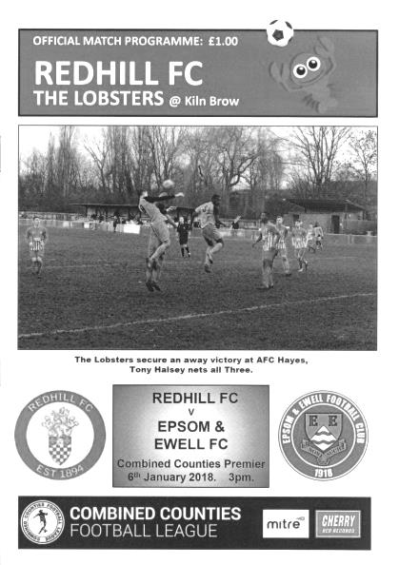
Salts fall away against Lobsters

A promising first half display fizzled out as Redhill defeated us by three clear goals at Kiln Brow on Saturday.

In the absence of Glyn Mandeville, Alex McKay and Neil Grant handed Samuel Marks his first appearance for the Salts and he played out on the left in a 4-2-3-1 formation with Germaine Jeannoel carrying the burden up front against a team that had smashed five past us before half time at High Road back in September.

It was also good to see Reisse Griffin available again, although McKay was injured so Sean White was given the Captain's armband in his final match before going travelling for a few months. Ashley Thompson and Scott Murphy returned in midfield and we started well. White opened up with a 25 yard effort that was just wide of Rhys Hughes' right hand post in the second minute, but in our next attack a good through ball down the right enabled Jeannoel to get to the ball in front of the advancing Hughes, rounding him and crossing the ball in to the unmarked Lloyd Connelly, but inexplicably he had run the ball just out of play before he did so. The visitors tried a long shot of their own but within moments we were attacking again with Jeannoel through on the left but his shot was well blocked by Hughes from just six yards out and the danger was cleared.

What we didn't realise at the time was that these would prove to be our best chances of the match as the home team weren't really troubled from that point. A clever one-two on the edge of our area finished with a low shot but Mohammed Mohammed was able to make a solid save. Shaun Masterson saw his shot blocked by a defender, but soon after we were caught out by a short corner and were fortunate to see their shot deflected just over our bar.

A Jeannoel header was blocked out for a corner by a defender but the set piece came to nothing and Lloyd Connelly did some good work to force errors from the opposition, but our possession was becoming less and less. We had a lucky escape on the half hour

when a shot was deflected into the path of a striker but he put his shot just wide of the goal from a good position.

However, as with many matches this season our good luck counted for nothing as Redhill took the lead in the 37th minute. A ball over the top of Noah Stew-Lewis was almost cut out but he was unable to prevent a low ball in from the left wing. Their striker received the ball ten yards out and cut inside a defender but we blocked the shot. However, the ball fell straight to Steve Burford who drilled the ball across Mohammed into the far corner of the net from about 12 yards.

On a boggy pitch that slowed down their speedy attackers I felt that we had every chance of getting back into the match in the second half but it just didn't happen, and if anything the home side took more of a grip over the proceedings. We introduced Liam Roberts for Masterson but, shortly after this we were caught out by another short corner and this time were fortunate to see a far post header go just wide of our post.

In the 69th minute Mohammed made a great save from a far post header that came from another corner. Unfortunately Redhill scored a second goal four minutes later and from where I was it looked like it had an element of fortune about it as a shot came in from the left hand side which Mohammed did well to save but as with the Walton & Hersham match seven days previously the loose ball fell straight to their man, in this case Burford who had a fairly easy tap in from close range to register his second goal.

We made further substitutions at this point and a change in formation but the damage was done and we were seeing less of the ball up front. Jeannoel was robbed by a good last minute tackle and a missed clearance by a defender gave substitute Ben Dyson a half chance but he sliced the ball and Hughes never even had to make the save. Mohammed made another good save from a low shot but once again it counted for little as a deep cross from the right wing was then headed past him from close range by the unmarked Jon Trotter in the 90th minute.

We had one final chance in injury time when Dyson set up Roberts, but he was crowded out and the opportunity for a consolation was gone. In fairness though this passage of play summed the match up as I thought Redhill covered a substantial amount of ground over the ninety minutes, and apart from the opening five minutes while they adapted to our formation they gave us very little space to work with all day.

Epsom and Ewell: Mustafa Mohammed, Noah Stew-Lewis, Sean White (c),
Adam Heagney, Reisse Griffin, Scott Murphy, Samuel Marks,
Ashley Thompson, Germaine Jeannoel, Shaun Masterson, Lloyd Connelly

Subs: Liam Roberts for Masterson (57), Endrit Dobraj for White (64),
Ben Dyson for Murphy (64)

From behind the goal
Godalming Town 1-2 Epsom & Ewell
Combined Counties League - Premier Division - Saturday 13th January 2018

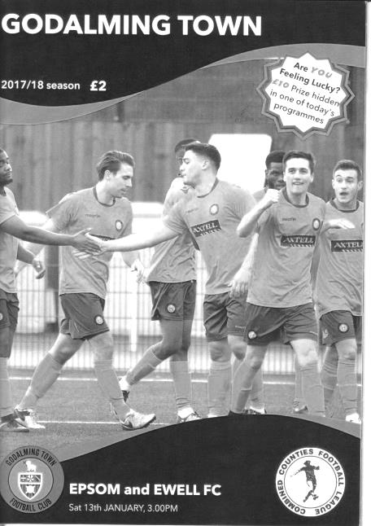
Impressive Salts display keeps season alive

On Saturday at Wey Court our team faced arguably its last chance of survival as we met Godalming Town, just one place but ten points ahead of us. If we were to have any realistic hopes of getting off the bottom of the table this was a must win fixture.

Going into the match on an eight league match losing run, our worst run of losses since 1971, was probably not the best preparation but our Management team brought in a couple of new faces and they both played a significant part in registering our first away League win since a 2-1 victory at Horley Town on Easter Monday.

In terms of personnel our two new boys were Marlon Pinder and Kyen Nicholas and both contributed a goal on their debuts. It was also good to see Ali Turpie back between the posts in place of the absent Mohammed Mohammed while Rob Hendry returned after missing the last couple of matches and Alex McKay was also back on the field after missing the Redhill trip through injury. Finally, there was also the welcome reappearance of something that had also been missing for a while, a team spirit, and it remained resilient throughout the 90 minutes, despite conceding first in the match.

The first opportunity in the contest came as early as the sixth minute when Hendry was fouled on the edge of the area by Josh Pound who required treatment for a while. In the meantime Hendry then bent the free kick over the wall and Dimitri Kyriatzis was forced into a very good save as the ball threatened to creep just inside his left hand post. In response the home team sent in a decent right wing cross but it was met by a soft looping header that was easy for Turpie before Hakim Griffiths blazed wide from a slightly wide position after 15 minutes. Unfortunately for us four minutes later he was unable to miss as a deep cross caught us out at the far post and was volleyed back across Turpie, hitting the far post and bouncing kindly for the Godalming striker to force the loose ball in.

This was a bit harsh on our boys because we had looked quite good going forward to this point and we were deservedly back on level terms within eight minutes. New boy Pinder, made a good run down the left wing before delivering a superb cross to the penalty spot and Nicholas was there to knock the ball past the advancing Kyriatzis from close range. It might not have been the cleanest contact but it was on target and it dribbled into the empty net to

make it one each. The two teams slugged it out for a while after this but cancelled each other out with no real chances on goal from either team. A long range shot from Nicholas was well over the bar, while a shot on target from the home team was straight at Turpie and another just missed his right hand post from distance. We had a different type of scare towards the end of the half when Nicholas went down with a head injury sustained as he challenged for a corner but he was able to recover after treatment and we went in at the half even at 1-1.

The home team would have been aware that they could climb a place with a win from this match and they came out to start the second half in a positive manner. We had some defending to do and had one concern when a long ball required Turpie to come out of his box to reach it first. However, in doing so he slipped over and we had a vacant goal for a little while. Fortunately the opportunity was snuffed out by a combination of Adam Heagney and Noah Stew-Lewis. Within a minute though they had attacked down the right instead and this resulted in a shot just wide of Turpie's post. Another minute later and another shot just cleared our bar from 12 yards. Things were getting a little concerning!

But there have been times this season when we have missed chances and been made to pay for it, and this time it was our turn to deliver retribution. Lloyd Connelly made a good run down the right wing and he put in a deep cross that caught out the home defence but not Pinder who timed his run well to meet the cross with a close range header into the net in the 59th minute. He nearly scored again six minutes later when he robbed a defender but his shot was well blocked by their keeper.

The home side pushed for an equaliser but didn't often look like getting one. Turpie was down to make a comfortable save before another shot went straight across our goalmouth and out for a goal kick but we were equally dangerous on the counter and substitute Samuel Marks was unfortunate to see his shot go wide of the post from an angle before Stew-Lewis made a great break down the right but with Nicholas waiting he sliced his cross, which instead became a shot on target that Kyriatzis did really well to keep out. Although Alex McKay had to make a good block of a low shot we saw out the remainder of the match fairly comfortably and in the process secured our first League points since defeating Farnham Town on 14th November.

Now the challenge is for us to keep the momentum going for the next matches with two important fixtures against Balham and Abbey Rangers up soon and we will be doing it under new stewardship following the resignation after the match of Glyn Mandeville. He will prove a hard act to follow after three years of good League positions but Caretaker Manager Neil Grant will now have the opportunity to see if he can salvage something from this season before it is too late. The chances of survival remain very slim, but for the first time in a while there is a light at the end of the tunnel.

Epsom and Ewell: Ali Turpie, Noah Stew-Lewis, Endrit Dobraj, Adam Heagney, Alex McKay (c), Ashley Thompson, Marlon Pinder, Scott Murphy, Kyen Nicholas, Rob Hendry, Lloyd Connelly

Subs: Samuel Marks for Hendry (69) Liam Roberts for Pinder (90), Ben Dyson for Nicholas (90)

Latest Results Grid
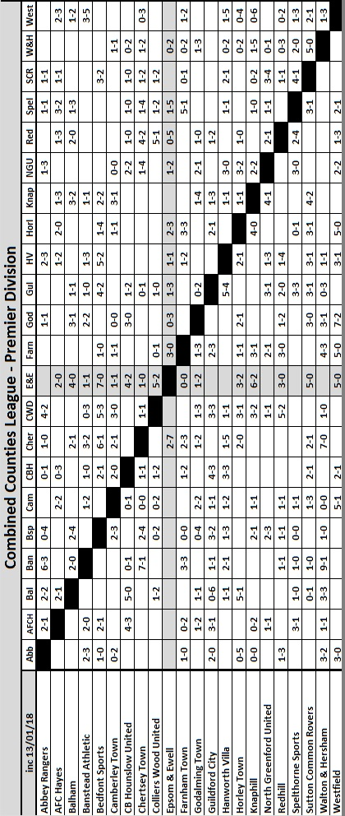

Surrey Senior Cup
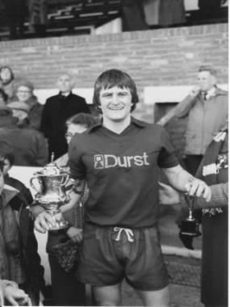
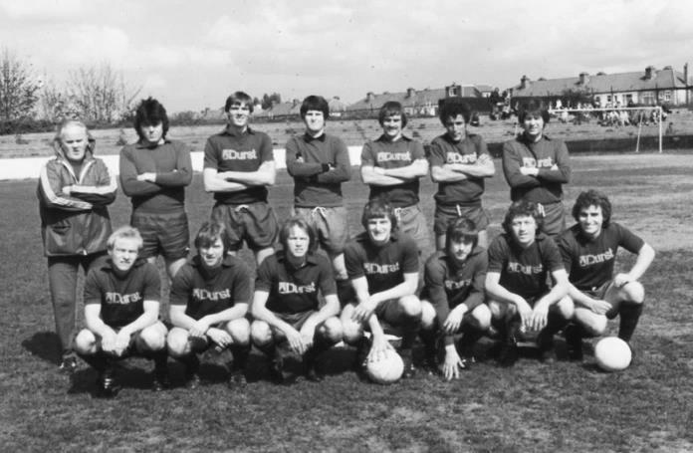

Preliminary Round
Westfield | 3-2 | Abbey Rangers
Dorking Wanderers | 4-1 | Walton Casuals
Knaphill | 1-2 | Met Police
First Round
Westfield | 2-2 - 4-2p | Camberley Town
Woking | 1-3 | Chipstead
Chertsey Town | 1-2 | Spelthorne Sports
Dorking Wanderers | 4-1 | Godalming Town
Horley Town | 0-2 | Kingstonian
AFC Croydon Athletic | 1-5 | Met Police
Tooting & Mitcham United | 1-0 | Corinthian Casuals
Carshalton Athletic | 6-2 | Egham Town
Croydon | 2-2 - 11-12p | Molesey
Farnham Town | 2-2 - 5-4p | Whyteleafe
Sutton United | 2-1 | Redhill
Banstead Athletic | 2-5 | Leatherhead
Sutton Common Rovers | 0-0 – 4-5p | Epsom & Ewell
Guildford City | 2-2 - 3-5p | Colliers Wood United
Merstham | 3-0 | Walton & Hersham
South Park | 2-2 - 4-2p | Ashford Town (Mx)
Second Round
Leatherhead | 24/1 | Kingstonian
Epsom & Ewell | 16/1 | Merstham
Farnham Town | 0-3 | Met Police
Westfield | 2-3 | Colliers Wood United
Spelthorne Sports | 23/1 | South Park
Sutton United | 7-1 | Molesey
Chipstead | 3-2 | Tooting & Mitcham United
Dorking Wanderers | 16/1 | Carshalton Athletic

Every Opponent A-Z
Over the years we have played many, many different opponents. Exactly how many is a difficult question, as it all depends on your definition. Are Camberley & Yorktown different to Camberley Town, or are Epsom Town different to Epsom F.C. or Epsom & Ewell F.C.?

In my analysis I have classed them as the same team, and will work through them all from A to Z. Some we have played many times, whilst others we have met maybe just once or twice. Enjoy!

Windsor & Eton / Windsor FC: Played 50 - W20 D12 L18 - F92 A90 - PPG - 1.44 - Average

For a club outside of our County, Windsor and their predecessor Windsor & Eton sit in our top ten for matches played. However, had we remained in the same league for a few more years they would have reached the top three, not far behind Tilbury and Uxbridge on 65 and 62 respectively.

Those two names might appear as a surprise to more recent supporters as we have played neither since 2000, while in that time we have met the Stags on 18 occasions. However, our meetings with the Stag Meadow based Windsor & Eton as they were originally named, started way back in 1950; the 11th February 1950 in fact, when we were in our very first Corinthian League season and we defeated them 2-1 at West Street, thanks to a Ken Minter goal and an own goal. Two weeks later they returned the favour with a 4-2 win on our first visit to Stag Meadow, picturesquely situated on the edge of Windsor Great Park. In fact the royal connection goes back further as Prince Philip was their patron for many years and with their location to the castle they had understandably been known as the Royalists for many decades.

After just one season as Corinthian League opponents, they left to join the Metropolitan League and then the Delphian in 1960 so we didn’t meet again until the 1965/66 season, by which time both leagues had been absorbed into the Athenian League. Our relegation from the old Corinthian Division (Division One) into the old Delphian Division (Division Two) ensured we would meet for seven seasons during the worst period in our history and although results were promising to start with; three wins, five draws and a 3-2 win at Stag Meadow in the Semi-Final of the Athenian League Division Two Cup, our record reversed dramatically from 1969 with one win and five losses and another Cup loss in the three years that followed. Our worst season on record in 1970/71 commenced with a 6-0 home defeat to Windsor & Eton; a fairly depressing way to start the season.

The 1972/73 season, our final one at Athenian level before being dispatched to the Surrey Senior League was another poor one, although we achieved a 1-1 draw there in December of 1972 before winning the return 2-1 at West Street on 27th January 1973 with goals from Alan Howe and Micky Dunne. Windsor remained in the Athenian League Division Two, so after our two season break in the County League we re-entered the Athenian League and smashed them 5-2 in November of 1975, although were held goalless in the return in February 1976. Fortunately we were promoted anyway and embarked on a few seasons of further success.

But then in 1982 they were promoted into the Isthmian League themselves under the astute guidance of a young Manager by the name of Geoff Chapple. Chapple first appeared on Epsom’s radar as a member of a Farnham Town team that defeated us in a 1966 Surrey Senior Cup tie, but he would go on to have major success in League and particularly the F.A. Trophy with Woking and Kingstonian after learning his trade here first. In 1982/83 they won the division below and so for 1983/84 we were League rivals once again. By now we had established ourselves under Adrian Hill, following the turbulence of the Pat O’Connell walkout that led to most of the players leaving too.

Windsor however, were better still and would go on to reach the Second Round of the F.A. Cup, drawing 0-0 at home to Harry Redknapp’s Bournemouth team and narrowly losing the replay with a home tie waiting against Manchester United in the Third Round which of course Bournemouth famously won! We lost at Stag Meadow on what was my first ever visit to the ground on 15th November 1983 and remember being so impressed with the ground that I wanted us to go back there frequently. That would certainly happen! Windsor would go up as Champions, despite a quite incredible display from our boys on 11th February 1984 when a hat trick from Steve Hill and one from Alan Morton enabled us to defeat them 4-0 at West Street and by the season’s end we would go up as runners-up behind them!

Our first season in the Isthmian League Premier Division ended with meetings very much in our favour. We edged them out of the League Cup 2-1 on a wet Tuesday in November when Ada Hill thanked us behind the goal for the constant noise that turned the game in our favour. Just eleven days later they were back again for a bizarre League match that ended 4-4 but the best was yet to come with one of our greatest ever displays with a 5-2 win in April 1985 when Tommy Tuite scored all five goals; a tally only exceeded once since that day. But the bubble was about to burst and after Hill’s departure to Croydon we went down the next season, narrowly losing 2-1 at Stag Meadow after leading and by 3-2 on a foul day at West Street. It was so wet I was sitting in the clubhouse, where I recall seeing our keeper Paul Riley miskick a back pass that led to the winner!

It was ten years before we would meet again by which time both clubs had found their way down to the Isthmian League Division Three, although they were destined to bounce straight back up and bashed us up 7-2 in March of that year, although we did win the return 4-1 at Merland Rise. Nearly two years later and by the same score line they became one of five Division Two victims on our run to the Final of the Associate Members Trophy in 1998. We then scored a late winner through Dale Marvell in September 2000 as we squeaked through a Vase tie 1-0 at Stag Meadow.

We were rising again and in 2002 we went up to the Division One South where we met Windsor & Eton once again for two seasons, narrowly losing 3-4 at Stag Meadow but winning the return 4-0, although the following season we lost 2-4 at home and scraped a point at Windsor in a 1-1 draw.

And that was that. Until 2011 when they folded and reformed as Windsor FC, dropping a step and playing in the Combined Counties League. Six seasons of League competition ensued with honours being very even over those 12 matches and we repeated our 2-0 League win from November 2016 in our last meeting to date; a League Cup Semi-Final at High Road in March 2017 with Matt Ferdinando and Jordan Gallagher finding the net.

That was our last meeting, but not our last visit as the Cup Final was held there when we were beaten 4-1 by Westfield. They were also prolific landlords and we have also played Slough, Wokingham and Bedfont Green there! They now play in the Hellenic League!

Player Sponsorship
Here is the latest list for 2017/18, with new photos showing all of our players and Management that are available for sponsorship. Other new players will be added as and when they arrive!

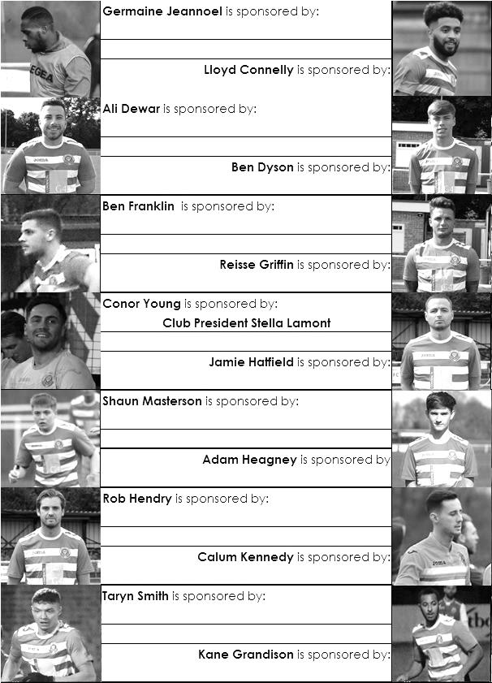

Sponsorship costs just £40 and it is easy to do. Just select a player who has not been previously sponsored and let a Committee Member know. Beware though. Until we have received the money it is possible for someone to jump in front of you, so don’t delay, sponsor today!

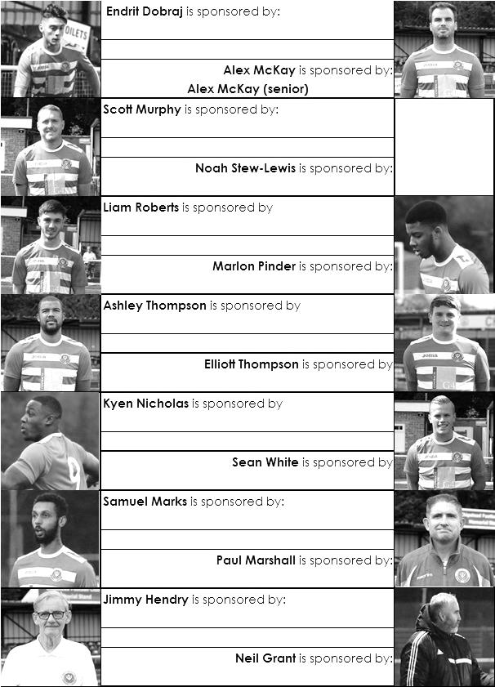

Match and Ball Sponsorships – 2017/18
Opponent | Date | Match Sponsor | Ball Sponsor
Banstead Athletic (FAC) | 06/08/17 | Club President - Stella Lamont
Chertsey Town | 15/08/17 | EEFC Management Committee
Redhill | 02/09/17 | Building Shop Ltd
Spelthorne Sports | 09/09/17 | In memory of Betty Dyke
Horley Town | 12/09/17 | Alex McKay (Senior)
Hanworth Villa | 23/09/17 | Jack Jarman
North Greenford United | 28/10/17 | Marvin and Kathy Hough
Farnham Town | 14/11/17 | In memory of Dave and Lizzie Marshall
Godalming Town | 21/11/17 | Building Shop Ltd
Guildford City | 02/12/17 | John Bonner
Walton & Hersham | 30/12/17 | Jeff and Arnold Pye
Merstham (SSC) | 16/01/18 | Paul Merritt
Balham | 20/01/18
Abbey Rangers | 23/01/18 | Pete Beddoe’s grandchildren  George, Joseph, Ezara & Inaya
Sutton Common Rovers | 03/02/18 | David Ellins
CB Hounslow United | 13/02/18
Knaphill | 24/02/18
Camberley Town | 10/03/18
Bedfont Sports | 24/03/18
Colliers Wood United | 30/03/18
Banstead Athletic | 02/04/18 | Nathan Lambert – 10 years old today!
Westfield | 14/04/18
AFC Hayes | 28/04/18 | Club President - Stella Lamont
Match sponsorship costs just £60.00!

Sponsorship includes:

Admission, programmes and hospitality for three people.

A full page advert in the programme and mascot for the day (if required).

Also, you get to choose the player of the match, who will receive a prize

If you are interested, just speak to a Committee Member,
or drop me an email at: richard.c.lambert@gmail.com

Salts Super Six Predictor
The Salts Super Six Predictor is sitting at £206 for today’s match. The tickets are on sale at today’s game to the left of the gate. The matches on the ticket are to be played on Saturday 20th January!

The competition is easy to play! To win, you simply need to predict the results of six matches correctly from the three options, fill in the form and make sure it is back with our seller before the deadline on the ticket. The latest fixtures are shown below.

If you are a club regular, you just need to place your name on the sheet, although if you aren’t, then we’ll need a contact number from you too. We will announce any winners on the website within three working days, so don’t worry, we won’t miss you!

Please note that if there is more than one winner, the prize pot would be shared between the winners. All you need to do now is have a go, as many times as you like!

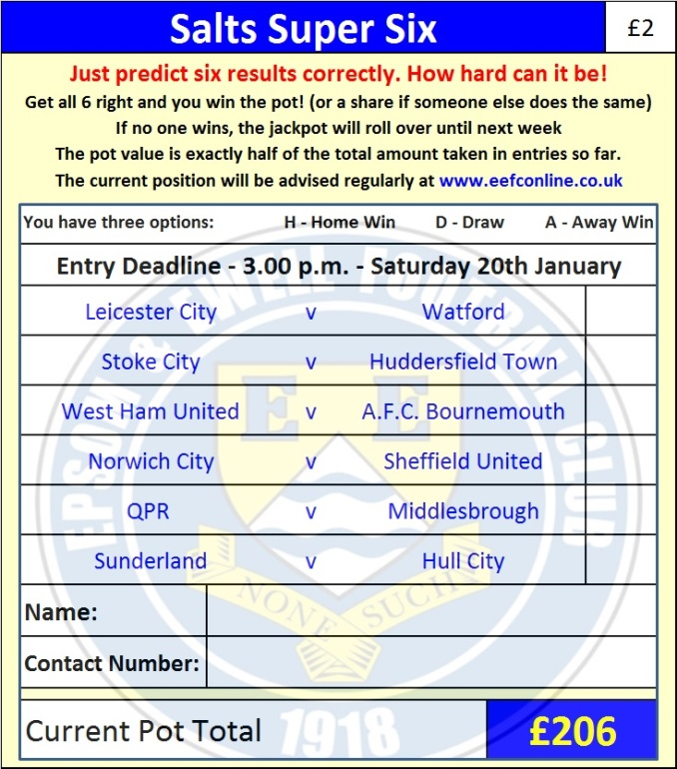

Good luck!

Surrey Senior Cup – Second Round
Tuesday, 16th January 2018 - Kick-off 7.45 p.m.
Epsom and Ewell  (Royal Blue & White hoops) | V |  | Merstham  (Amber and Black, Black)
Squad | NUMBERS |  | Squad
Conor Young |  |  | Chris Haigh
Noah Stew-Lewis |  |  | Michael Abnett
Endrit Dobraj |  |  | Ben Harrison
Adam Heagney |  |  | Tom Kavanagh
© Alex McKay |  |  | Liam Harwood
Ashley Thompson |  |  | Matt Drage
Marlon Pinder |  |  | Alex Addai
Scott Murphy |  |  | Kershaney Samuels
Kyen Nicholas |  |  | Tom Collins
Rob Hendry |  |  | Ryan Hall ©
Lloyd Connelly |  |  | Alberto Lumbango
Samuel Marks |  |  | Tutu Henriques
Ben Dyson |  |  | Dean McDonald
Liam Roberts |  |  | Antone Douglas
Ali Turpie |  |  | Malik Onwugbonu
Germaine Jeannoel |  |  | Stephan Hamilton-Forbes
Ben Franklin |  |  | Sean Bonnett-Johnson
Shaun Masterson
Kane Grandison
Calum Kennedy
Troy Williams
Reisse Griffin
Taryn Smith
Ali Dewar
Neil Grant | MANAGER |  | Hayden Bird
Alex McKay | ASSISTANT |  | Tutu Henriques
Jimmy Hendry | COACH / PHYSIO |  | Ryan Valentine
REFEREE: S.Elson SCFA Represenative: T.Newman
ASSISTANTS: S.Orchard, S.Matthews
Today’s Match and Match Ball are kindly sponsored by:
long serving supporter Paul Merritt

OUR NEXT VISITORS TO HIGH ROAD
Balham
Cherry Red Combined Counties League – Premier Division
Saturday 20th January 2018 – 3.00 p.m.

